|  |
| --- |
| ***Date: / / 18***  **[cloud computing]** |
|  |

Practical: 6

**AIM: Amazon Web Services(EC2)**

Submitted By: Samip Shah

Enrollment No: 15012011045



**GANPAT UNIVERSITY**

**U. V. Patel College of Engineering**

**Computer Engineering Department**

* **Introduction Of AWS?**

Amazon Web Services (AWS) can be defined as the huge set of on-demand services provided to the customers on cloud with pay-as-you-go pricing method. Whether it is about configuring a server or running an application, AWS lets you execute your operations on cloud in a similar way as you would do on a physical computer. You can correlate it with the consumption of electricity where you pay as much as you utilize.

* **AWS product categories**

AWS offers a wide range of services that can be categorized in following categories –

* Compute and Networking Services
* Storage and Content Delivery Services
* Security and Identity Services
* Database Services
* Analytics Services
* Application Services
* Management Tools
* **Introduction OfAmazon EC2?**

Amazon Elastic Compute Cloud (Amazon EC2) is a web service that provides secure, resizable compute capacity in the cloud. It is designed to make web-scale cloud computing easier for developers.Amazon EC2’s simple web service interface allows you to obtain and configure capacity with minimal friction. It provides you with complete control of your computing resources and lets you run on Amazon’s proven computing environment. Amazon EC2 reduces the time required to obtain and boot new server instances to minutes, allowing you to quickly scale capacity, both up and down, as your computing requirements change.

* **EC2 Components**

1. **Operating System Support**

Amazon EC2 supports multiple OS in which we need to pay additional licensing fees like: Red Hat Enterprise, SUSE Enterprise and Oracle Enterprise Linux, UNIX, Windows Server, etc. These OS needs to be implemented in conjunction with Amazon Virtual Private Cloud (VPC).

1. **Security**

Users have complete control over the visibility of their AWS account. In AWS EC2, the security systems allow create groups and place running instances into it as per the requirement. You can specify the groups with which other groups may communicate, as well as the groups with which IP subnets on the Internet may talk.

1. **Pricing**

AWS offers a variety of pricing options, depending on the type of resources, types of applications and database. It allows the users to configure their resources and compute the charges accordingly.

1. **Fault tolerance**

Amazon EC2 allows the users to access its resources to design fault-tolerant applications. EC2 also comprises geographic regions and isolated locations known as availability zones for fault tolerance and stability. It doesn’t share the exact locations of regional data centers for security reasons.

1. **Migration**

This service allows the users to move existing applications into EC2. This service suits those users having large amount of data to move.

* **Features of EC2**

1. **Reliable**

Amazon EC2 offers a highly reliable environment where replacement of instances is rapidly possible. Service Level Agreement commitment is 99.9% availability for each Amazon EC2 region.

1. **Designed for Amazon Web Services**

Amazon EC2 works fine with Amazon services like Amazon S3, Amazon RDS, Amazon DynamoDB, and Amazon SQS. It provides a complete solution for computing, query processing, and storage across a wide range of applications.

1. **Secure**

Amazon EC2 works in Amazon Virtual Private Cloud to provide a secure and robust network to resources.

1. **Flexible Tools**

Amazon EC2 provides the tools for developers and system administrators to build failure applications and isolate themselves from common failure situations.

1. **Inexpensive**

Amazon EC2 wants us to pay only for the resources that we use. It includes multiple purchase plans such as On-Demand Instances, Reserved Instances, Spot Instances, etc. which we can choose as per our requirement.

**Create an AWS Ec2 Windows and linux instance and host a website.**

**How To Create Account in Amazon Web Services :**

1. **Go to https://aws.amazon.com to create an account.**

**(It is free for 1 year, a credit card / debit card and mobile number is required) then click on “create a new aws account”.**

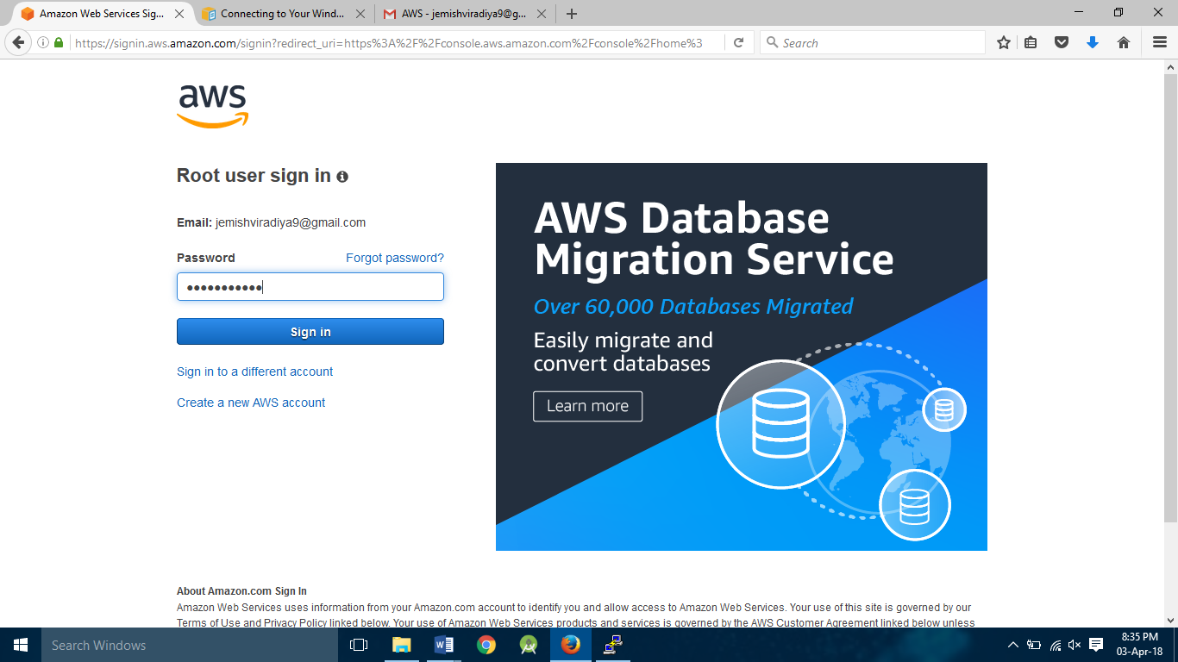

1. **Enter login information .**

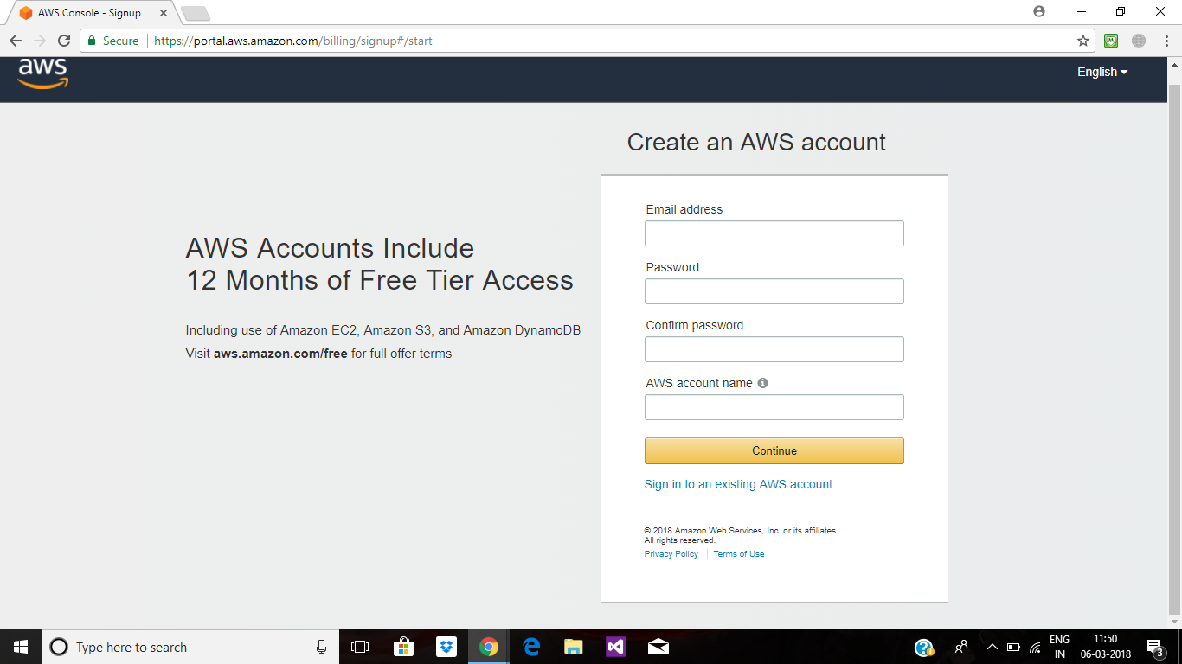

1. **Select personal and fill other information.**

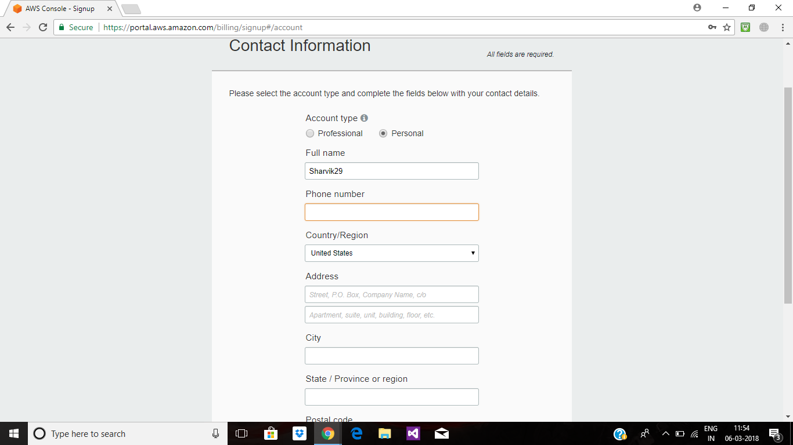

1. **Enter credit card details and make payment.**

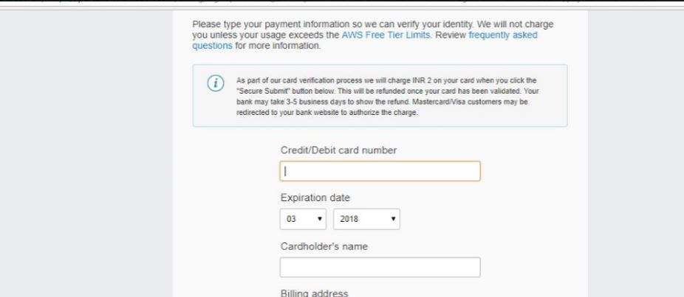

**Enter your mobile number and verified your identity. After verifying identity your account will create.**

**windows instance**

1. **Login into AWS account.**



1. **Select EC2 in compute**

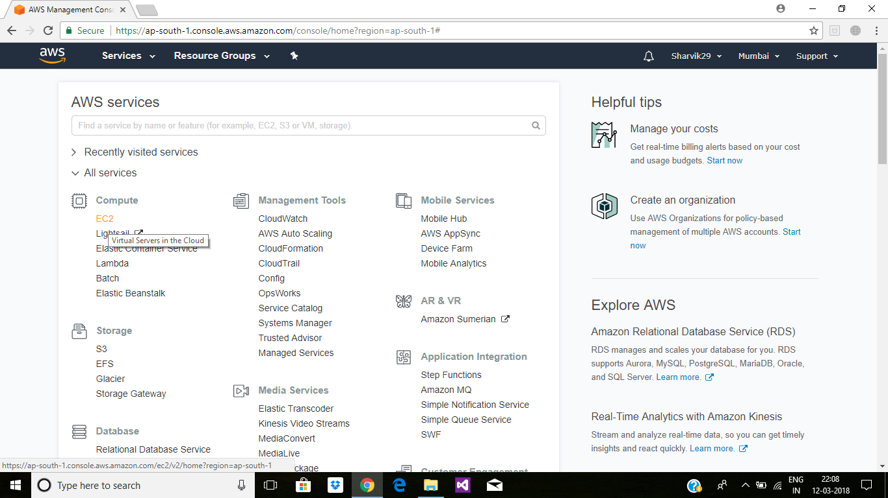

1. **After selecting EC2 you can see EC2 dashboard where you can see information**

**regarding your created instance.**

**To create new instance click on Launch Instance button.**

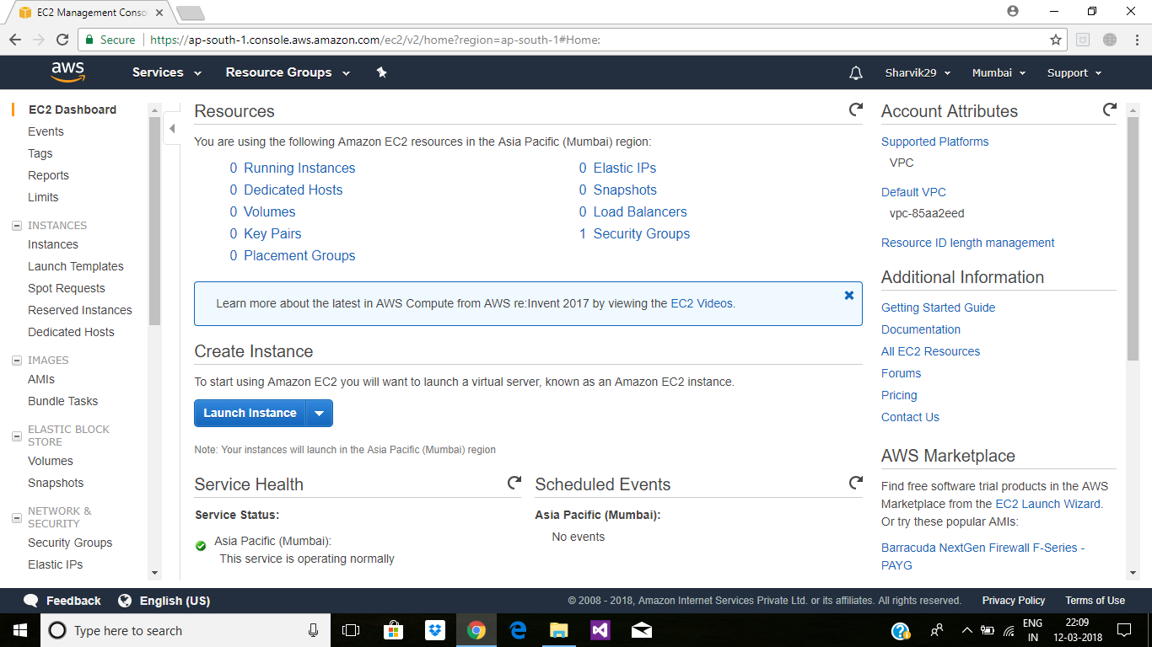

1. **Select free tire only checkbox and choose Amazon Machine Image(AMI).**

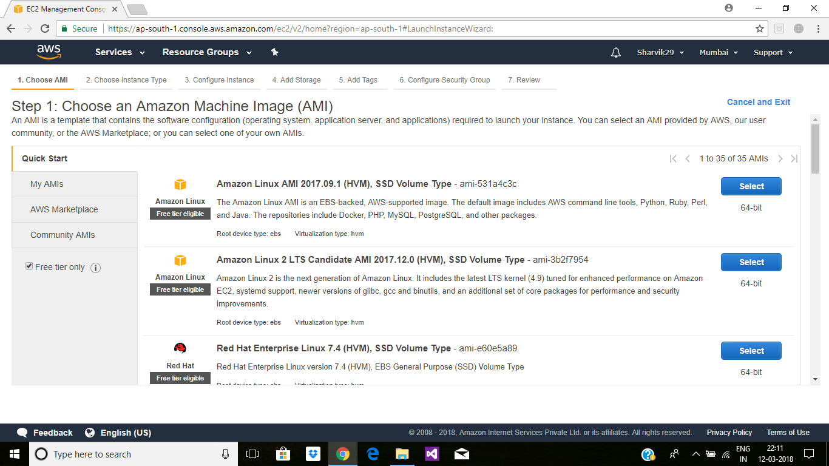

**Here we select windows server 2016 base**

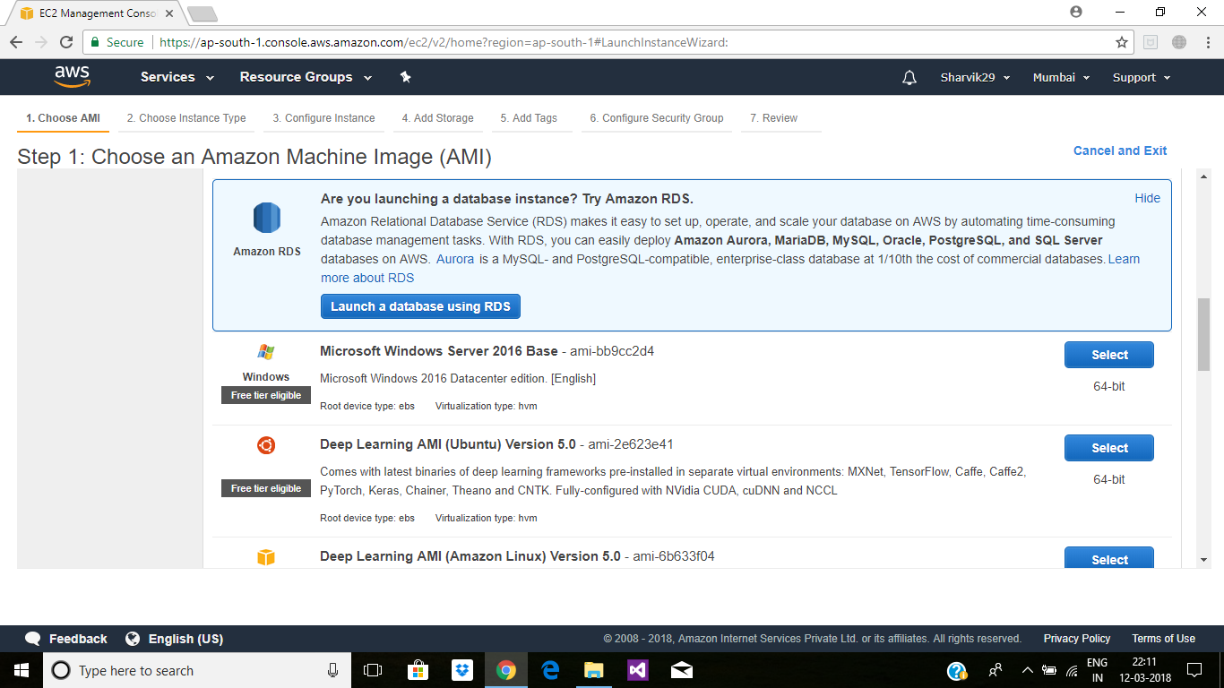

1. **Choose Instance (check free tire eligible) and click on next.**

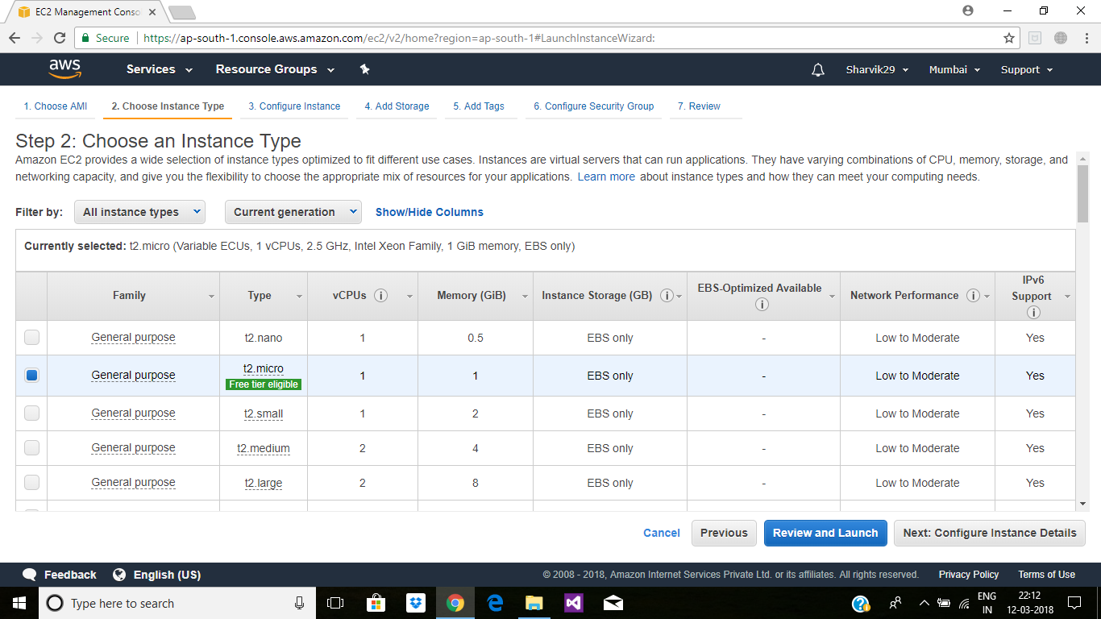

1. **In Configure Instance Details no need to change anything->click on next.**

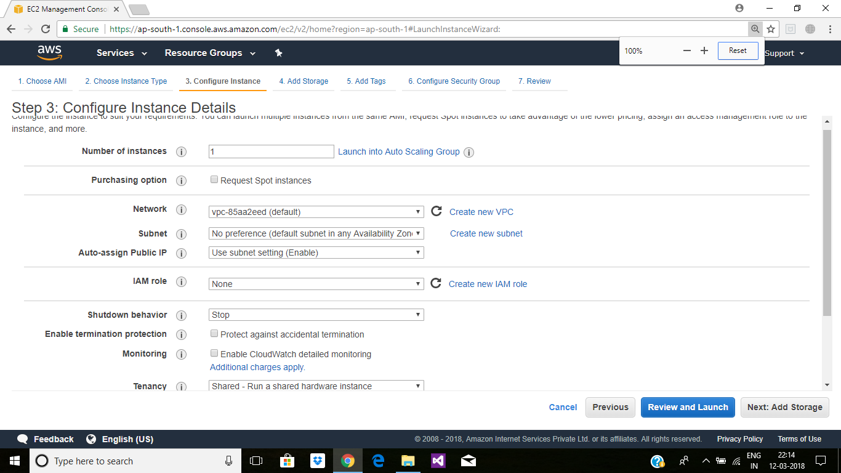

1. **In Add Storage check information regarding storage and click on Add tags.**

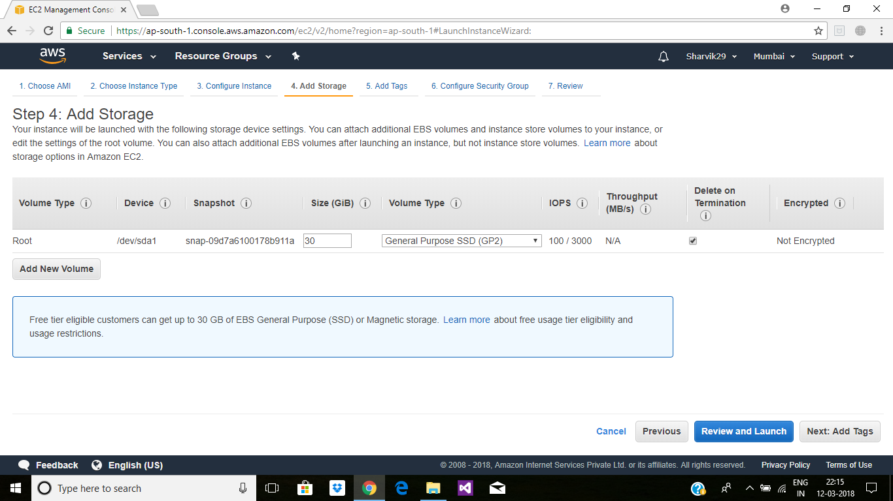

1. **In Add Tags give key and value to your instance than click on next.**

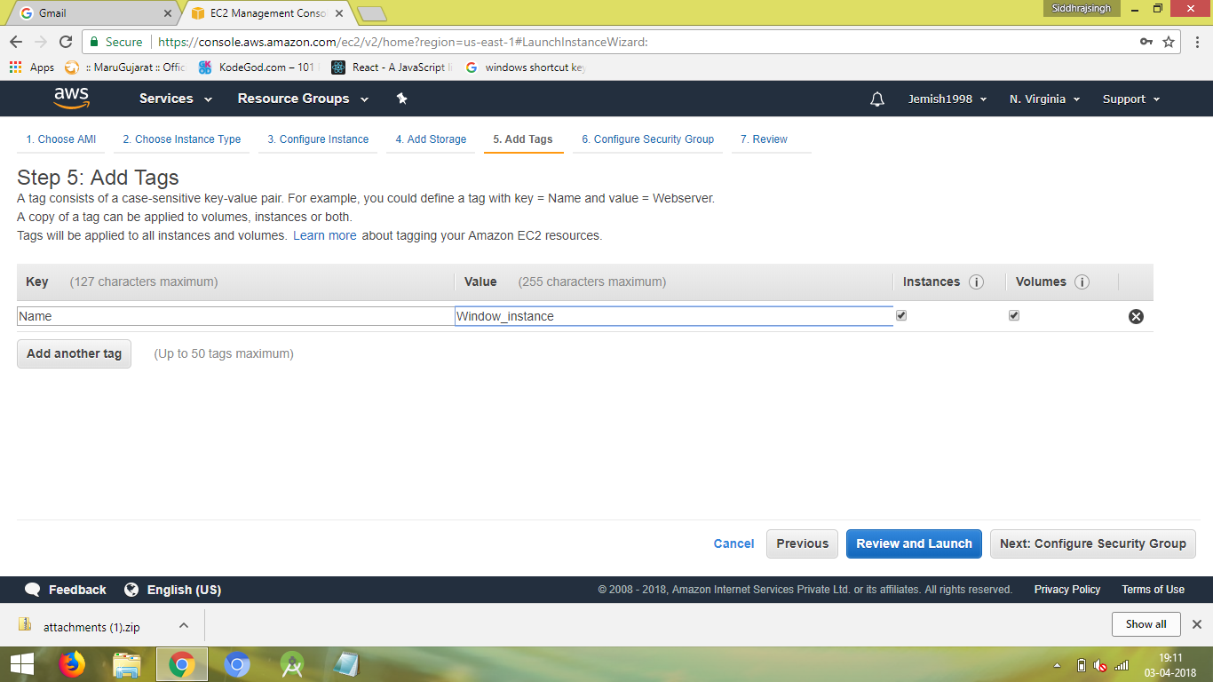

1. **In Configure the Security Group you can select security group according to your requirement.**

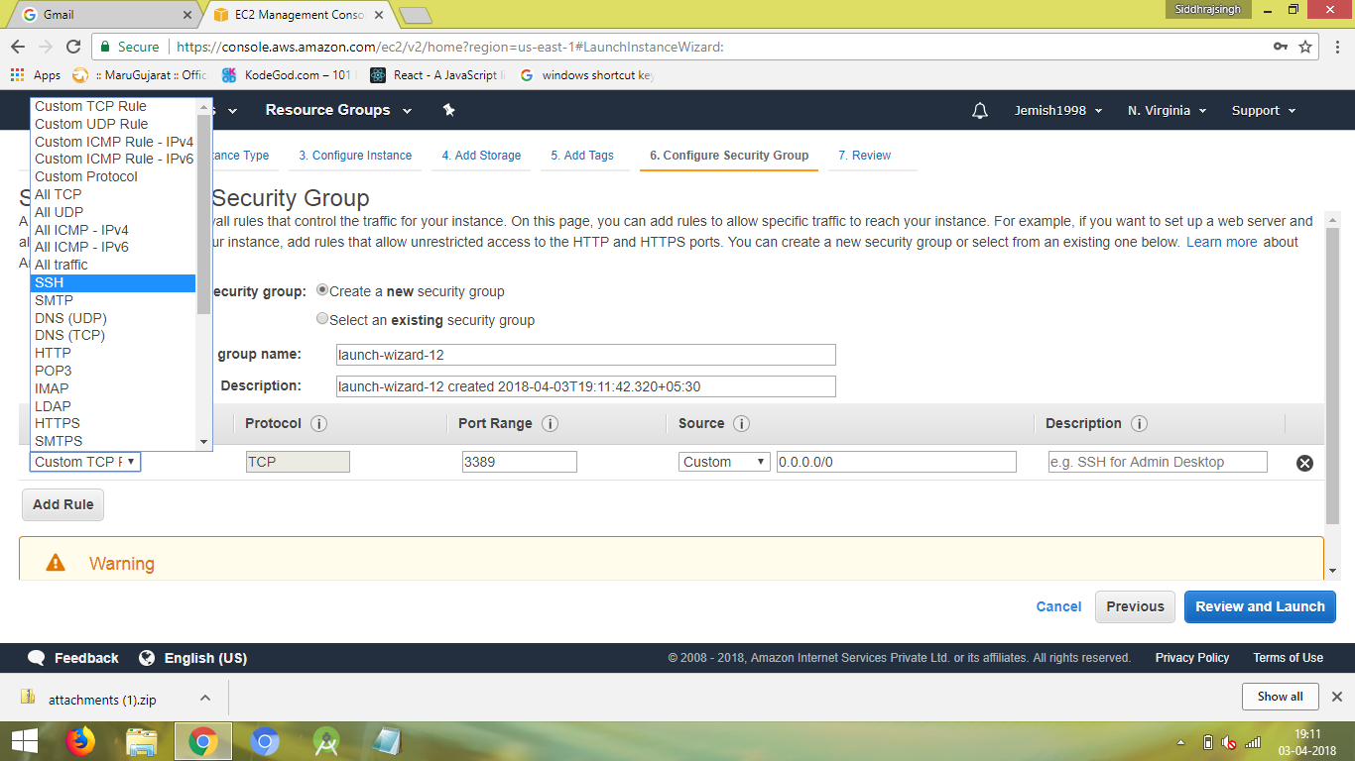

**Click Review and Launch**

1. **In Review Instance you can see all information about your**

**instance and click on Launch.**

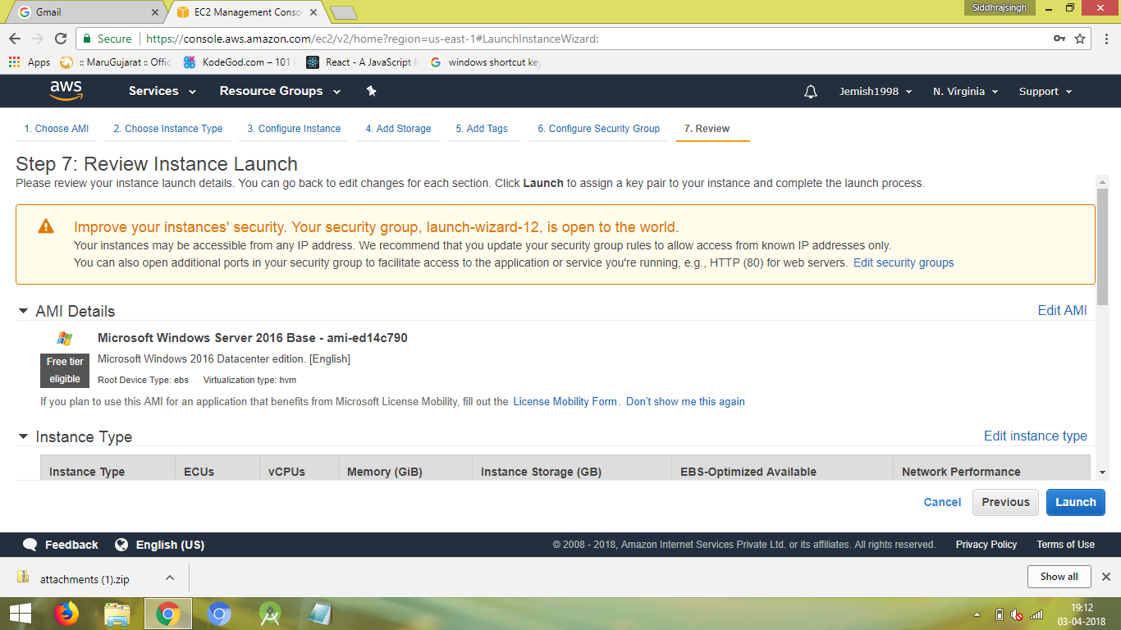

1. **When you click on launch you will ask to download key pair.**

For that select create new key pair and enter key pair name and Download key pair.

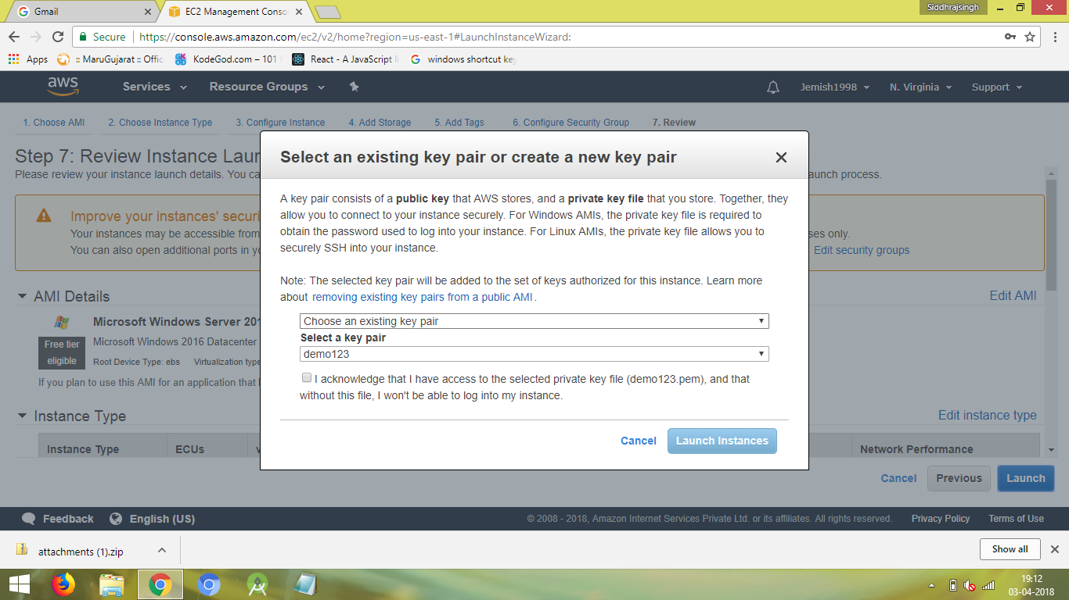

**After downloading click on launch instance.**

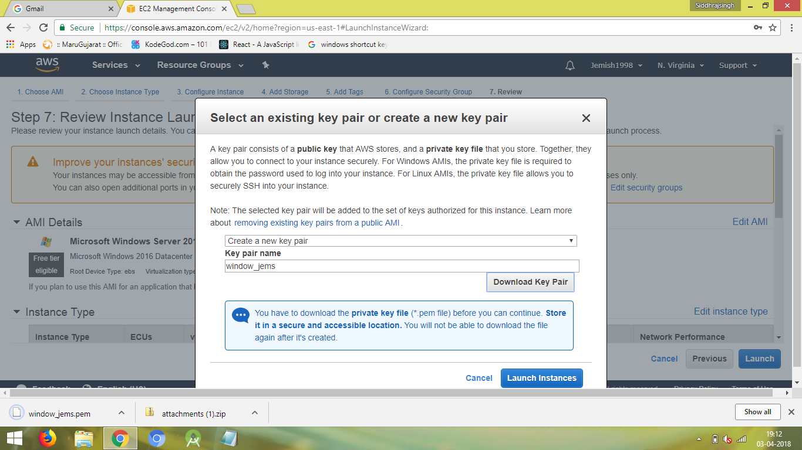

1. **you can see on Ec2 dashboard one instance is Running (Windows Instance)**

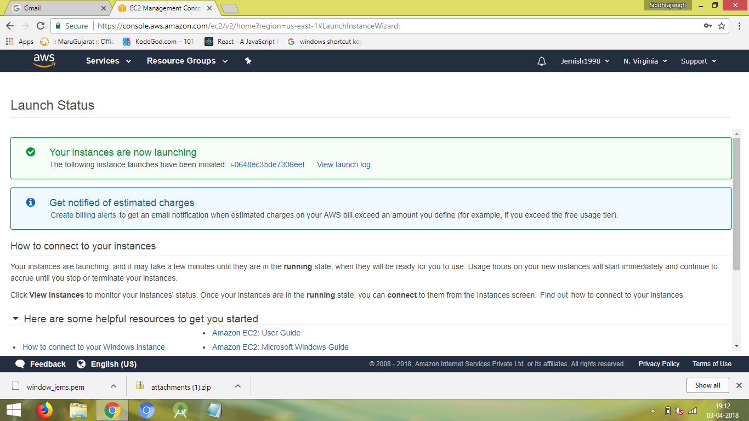

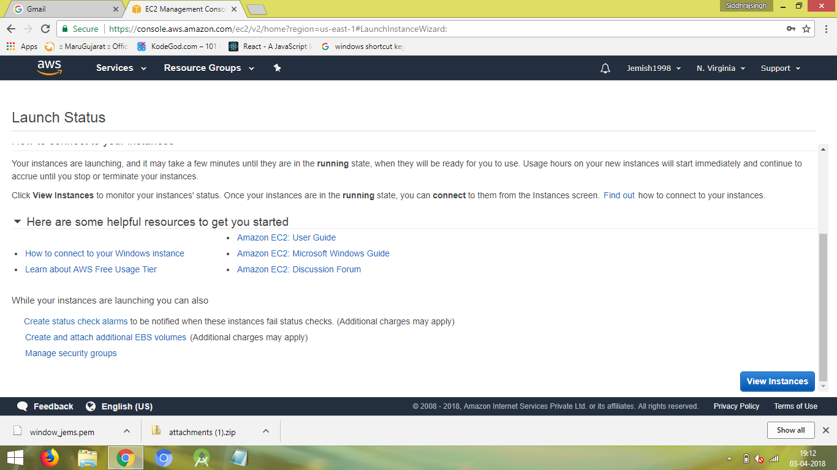

**Click on View Instance**

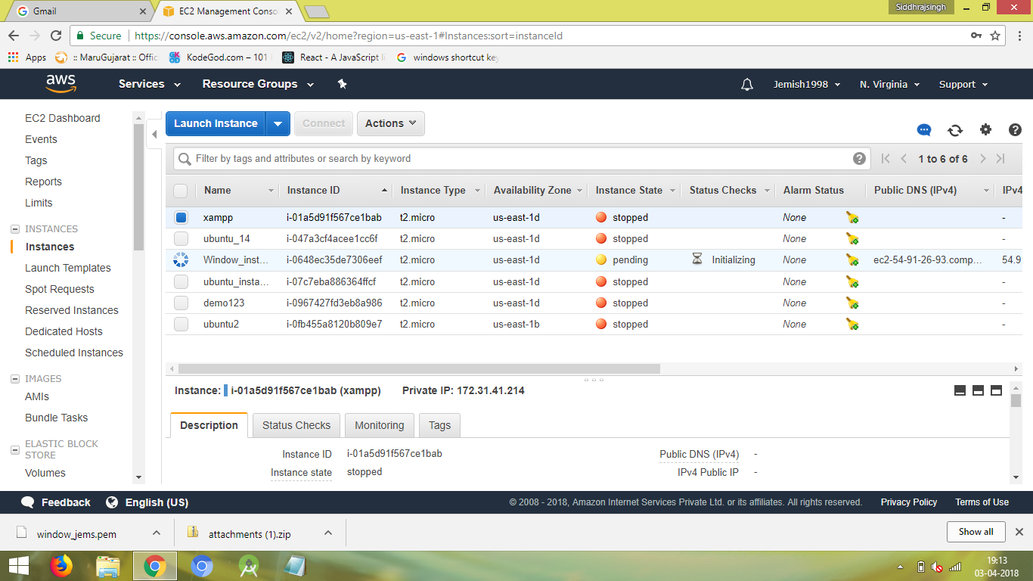

1. **Now Click on connect and Download the Remote desktop file and get a password.**

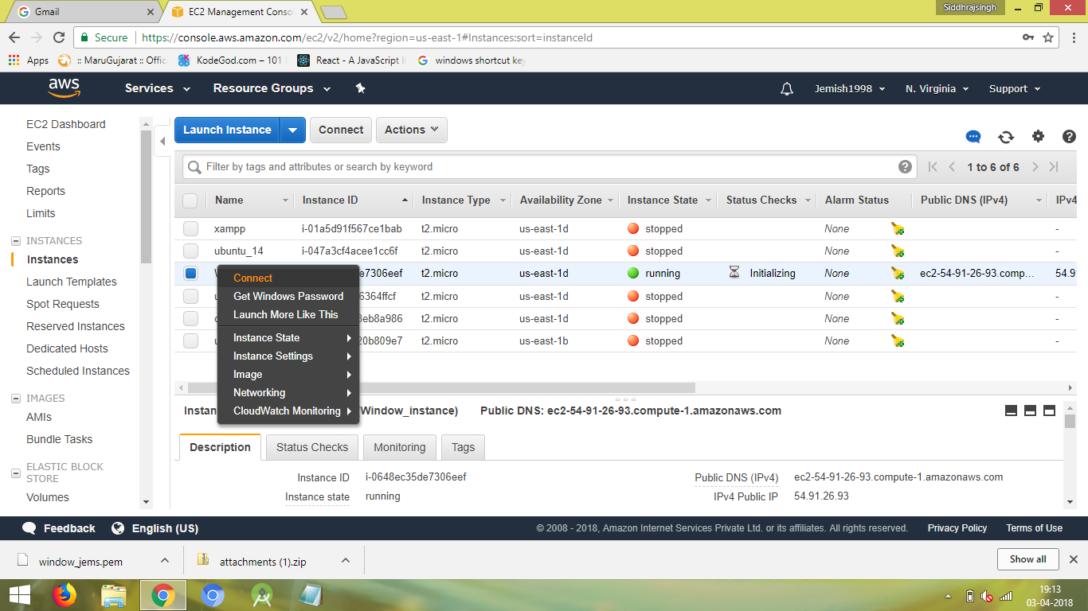

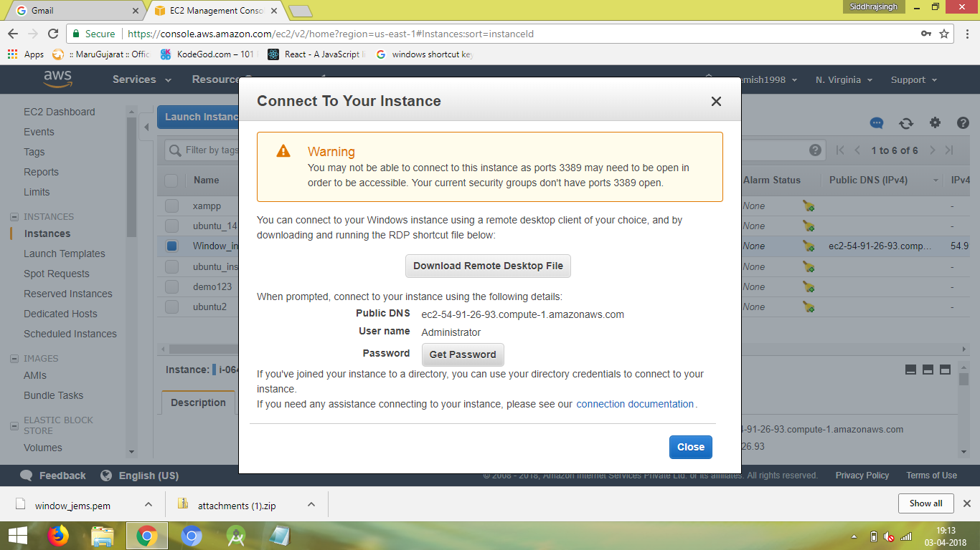

1. **Click on Get Password and put generated key for decryption**

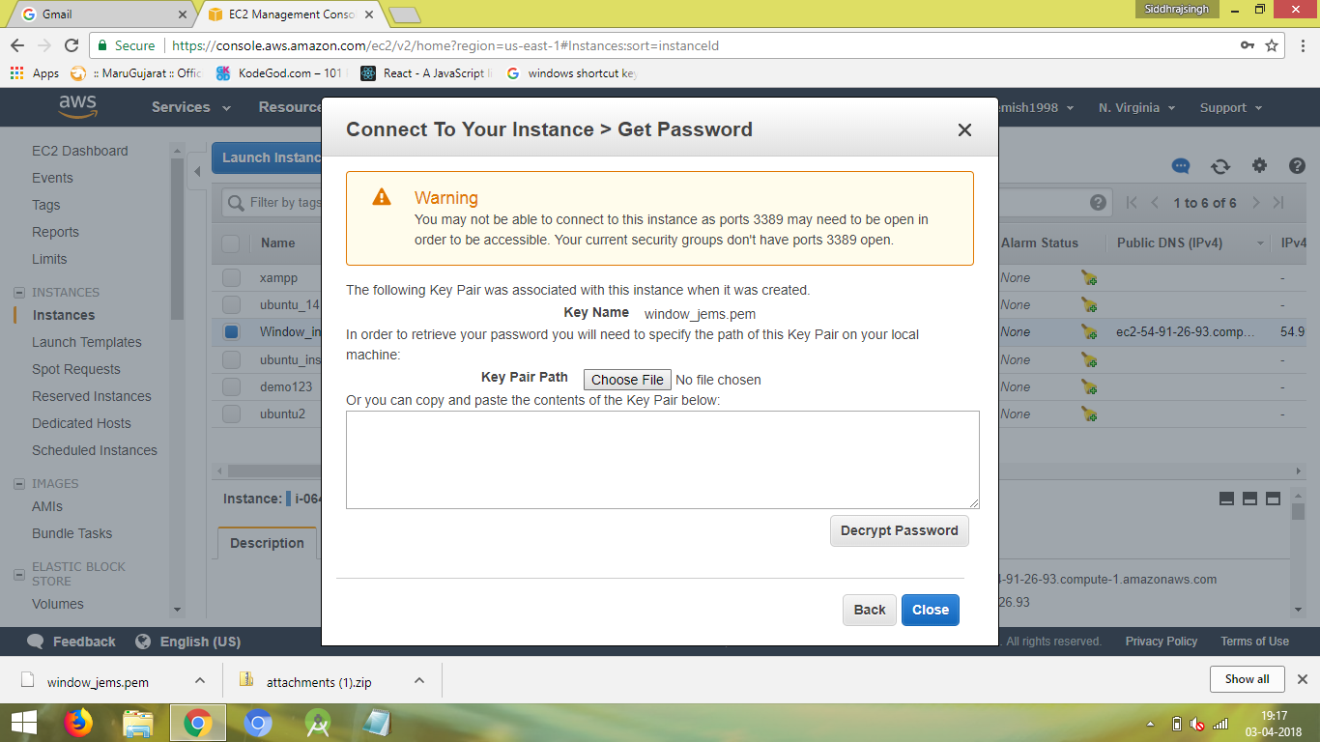

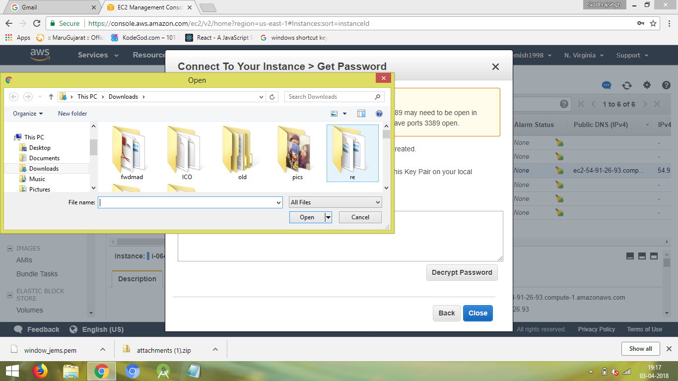

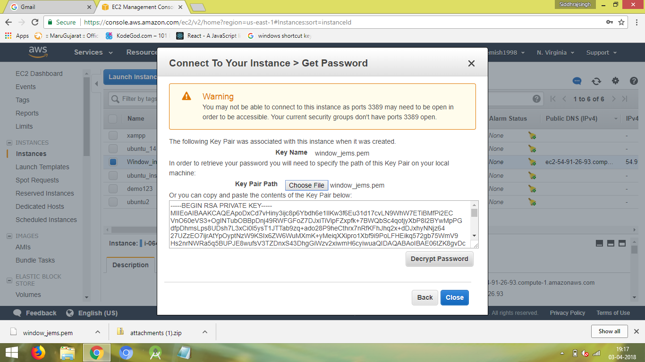

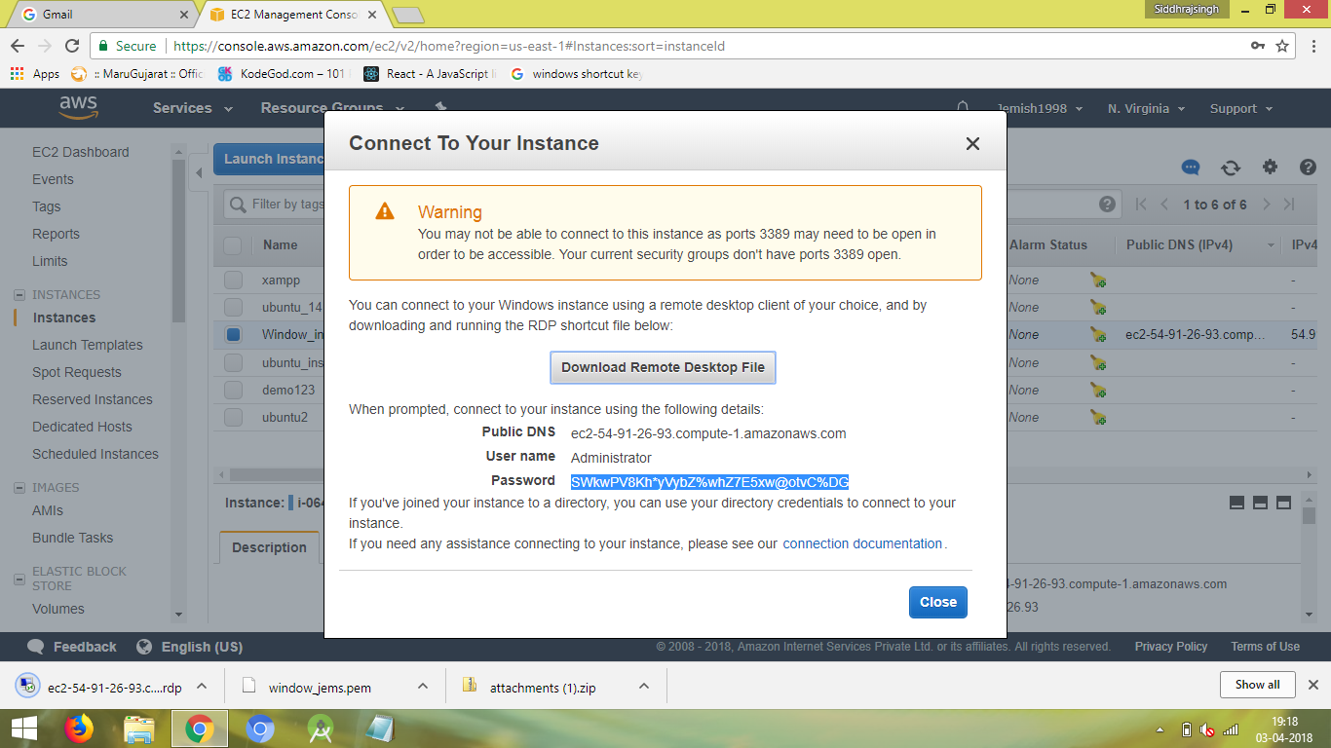

1. **Download and Connect Remote Desktop Files**

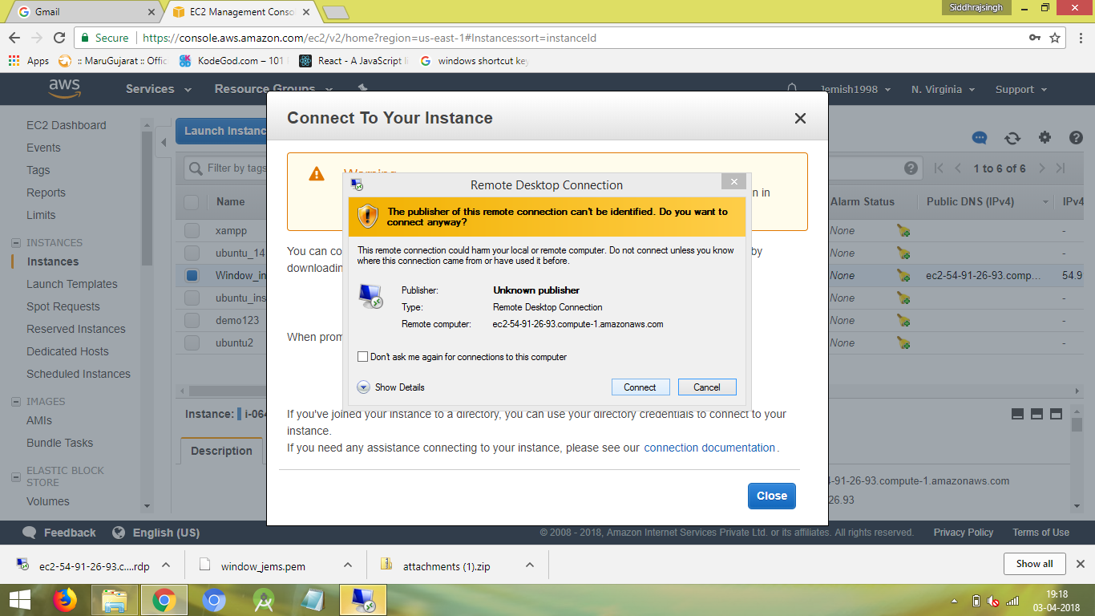

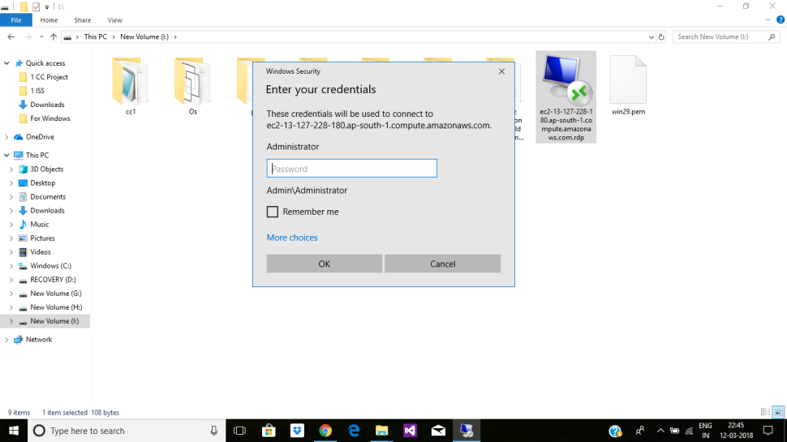

1. **Enter the password**

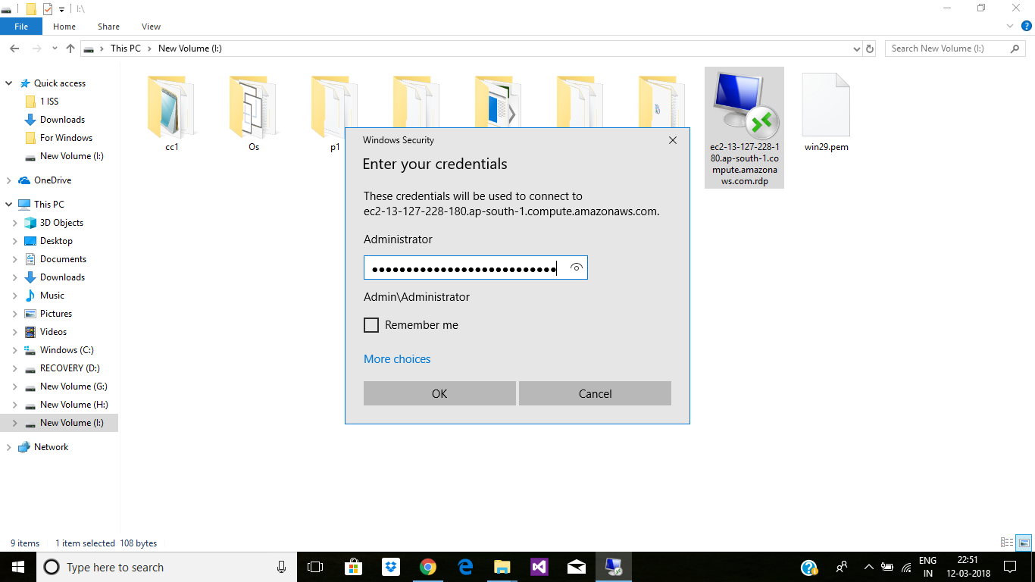

1. **Connect to Remote Computer click on yes.**

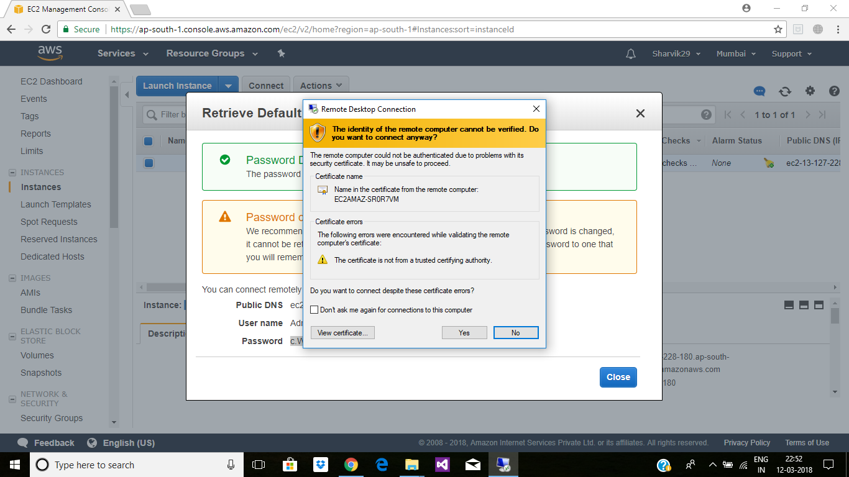

1. **Virtual Machine created**

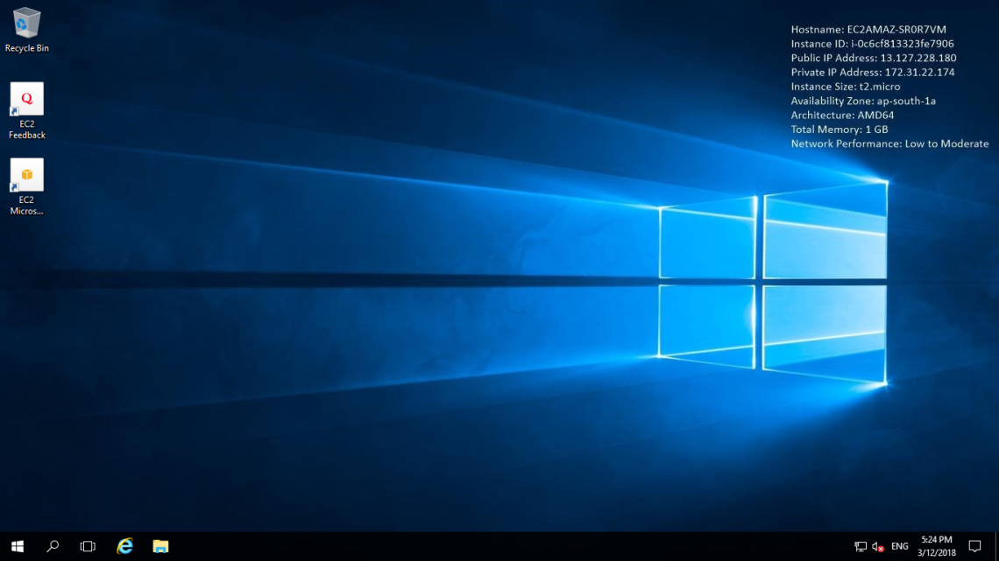

1. **Go to Browser and download the xampp**

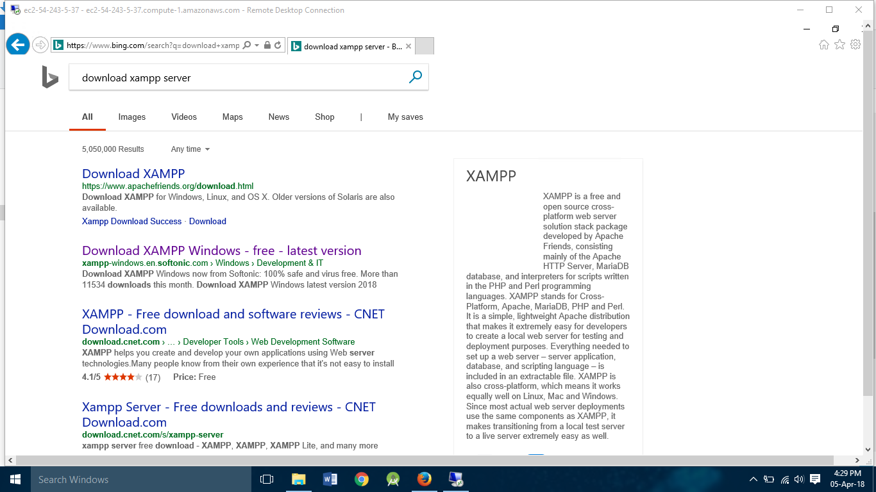

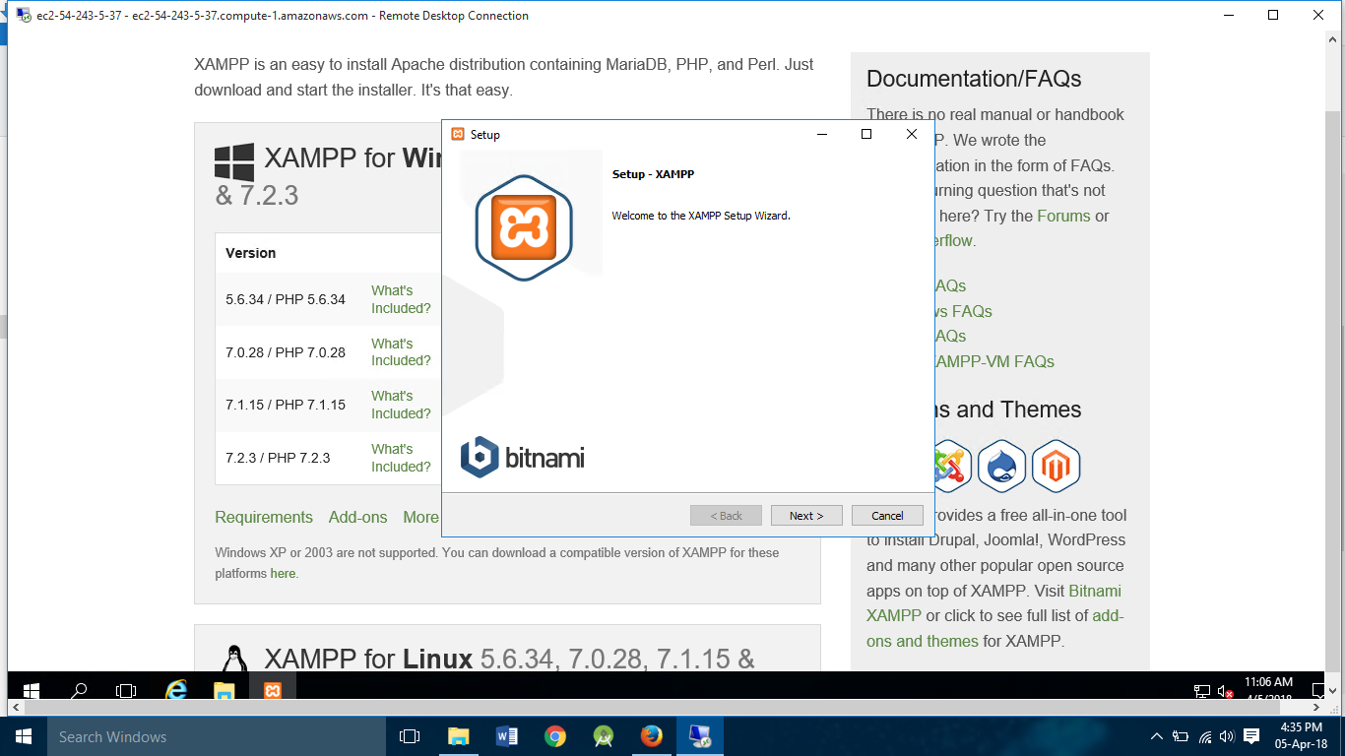

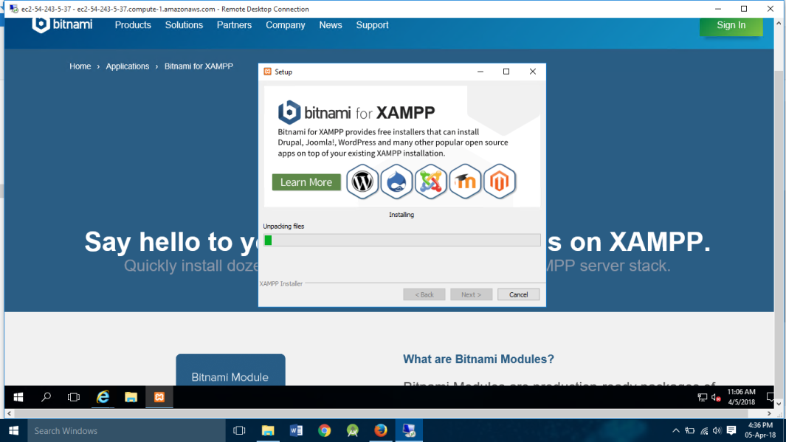

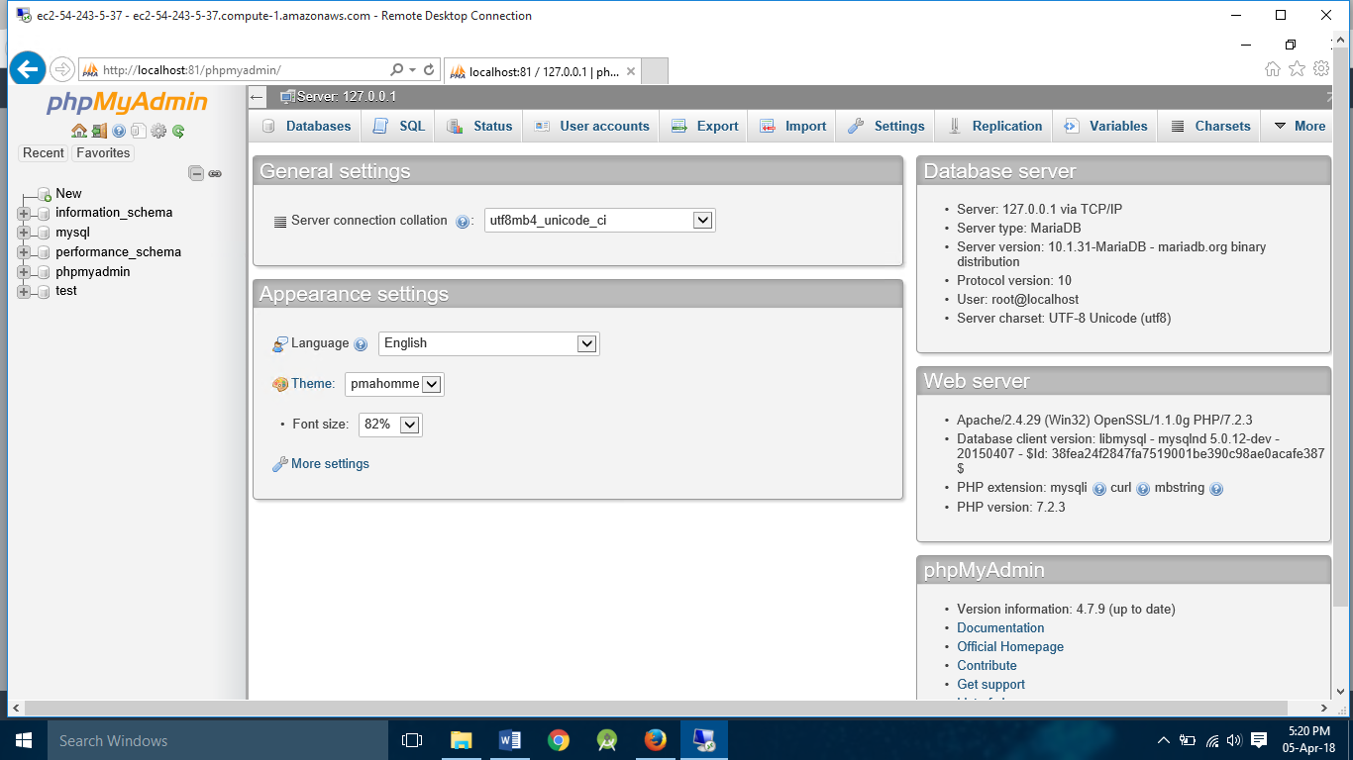

1. **Input all file in xampp->htdocs->file_name**

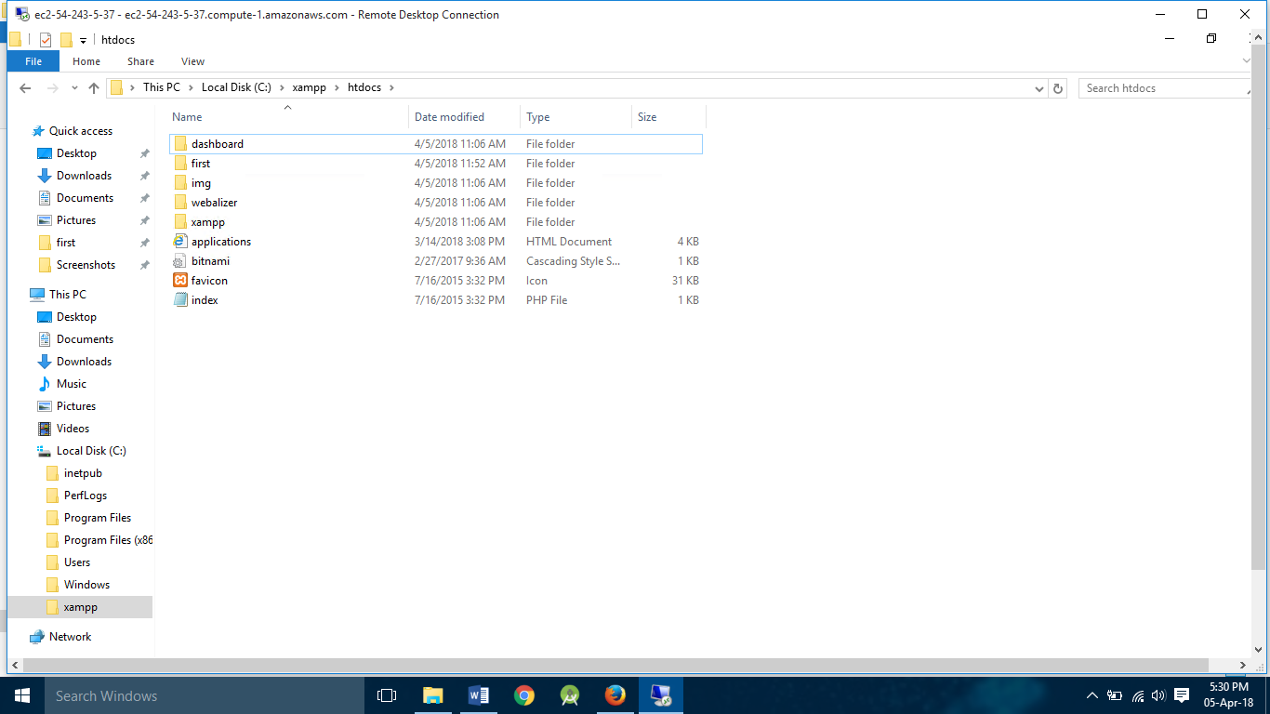

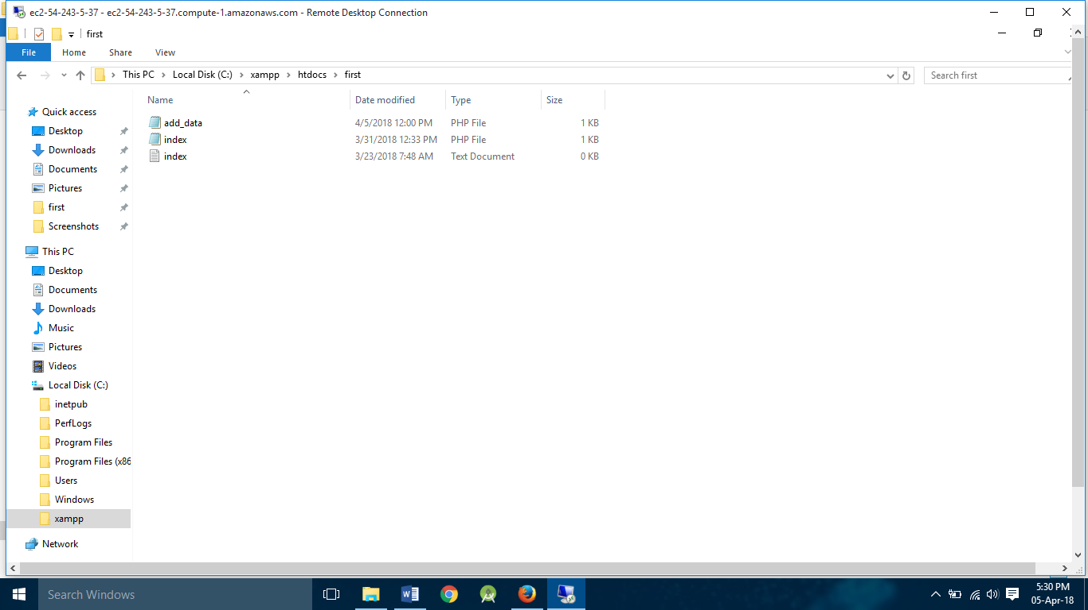

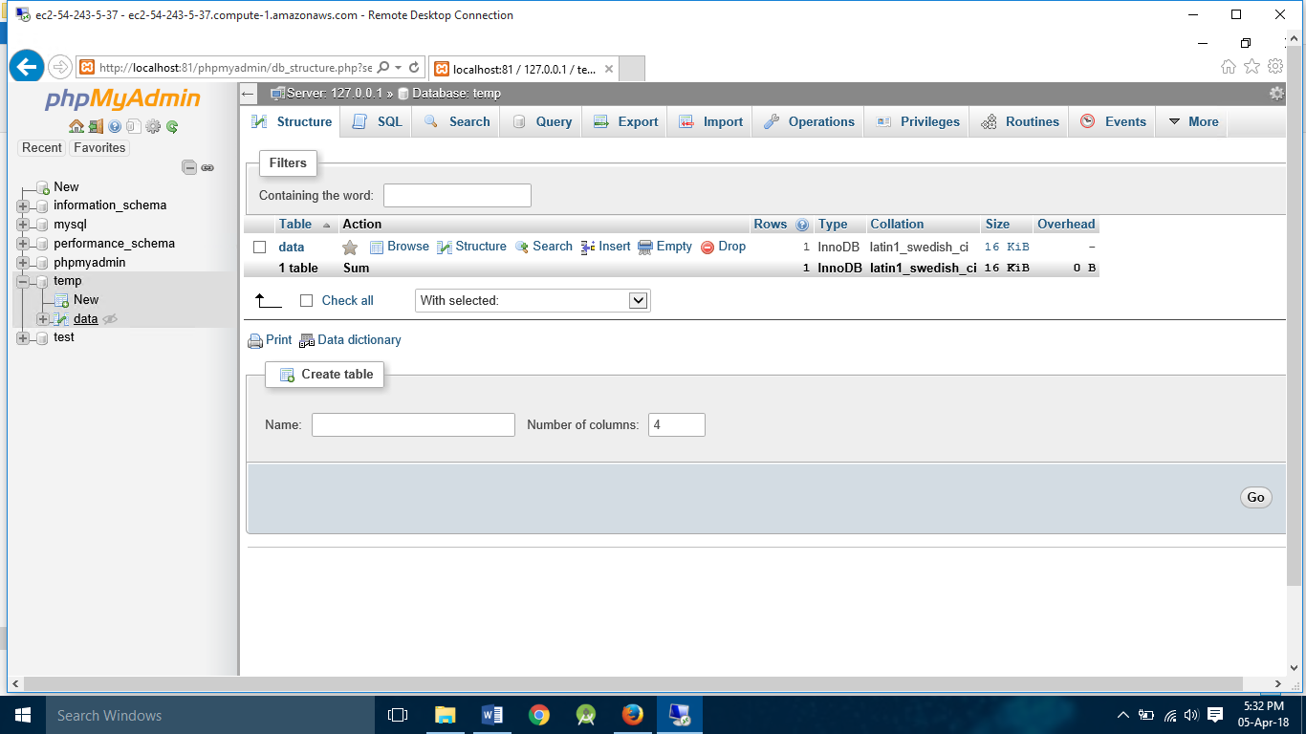

1. **Host the website on the iis server(localhost/folder name/index.html)**

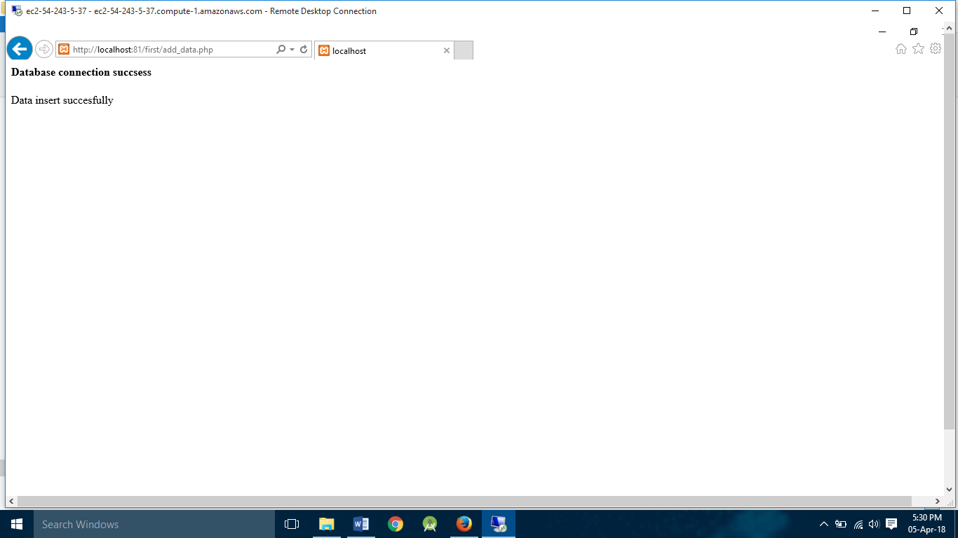

**Linux Instance**

1. **Log in into AWS account and choose Linux(Ubuntu)EC2 Instance.**

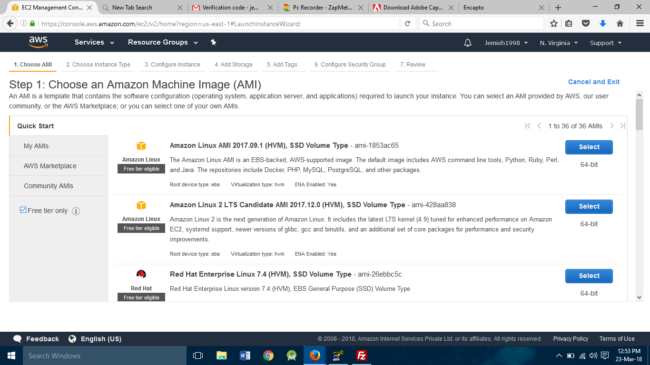

1. **Choose Instance (check free tire eligible) and click on next.**



1. **In Configure Instance Details no need to change anything->click on next.**



1. **In Add Storage check information regarding storage and click on Add tags.**



1. **In Add Tags give key and value to your instance than click on next.**



1. **In Configure the Security Group you can select security group according to your requirement.**



**Click Review and Launch**

1. **In Review Instance you can see all information about your**

**instance and click on Launch.**

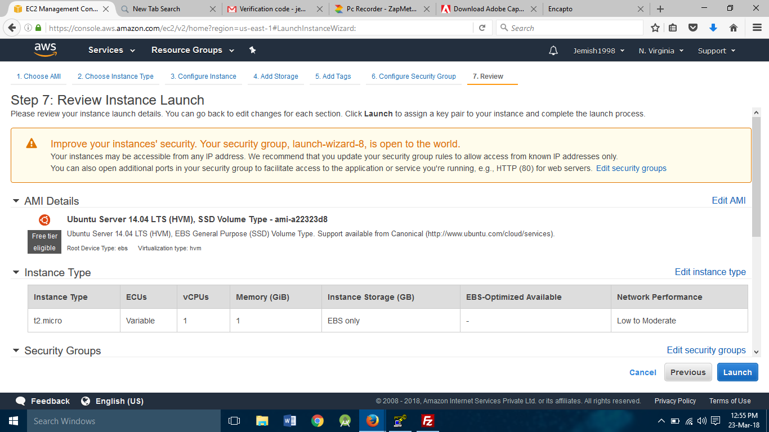

1. **When you click on launch you will ask to download key pair.**

**For that select create new key pair and enter key pair name and Download key**

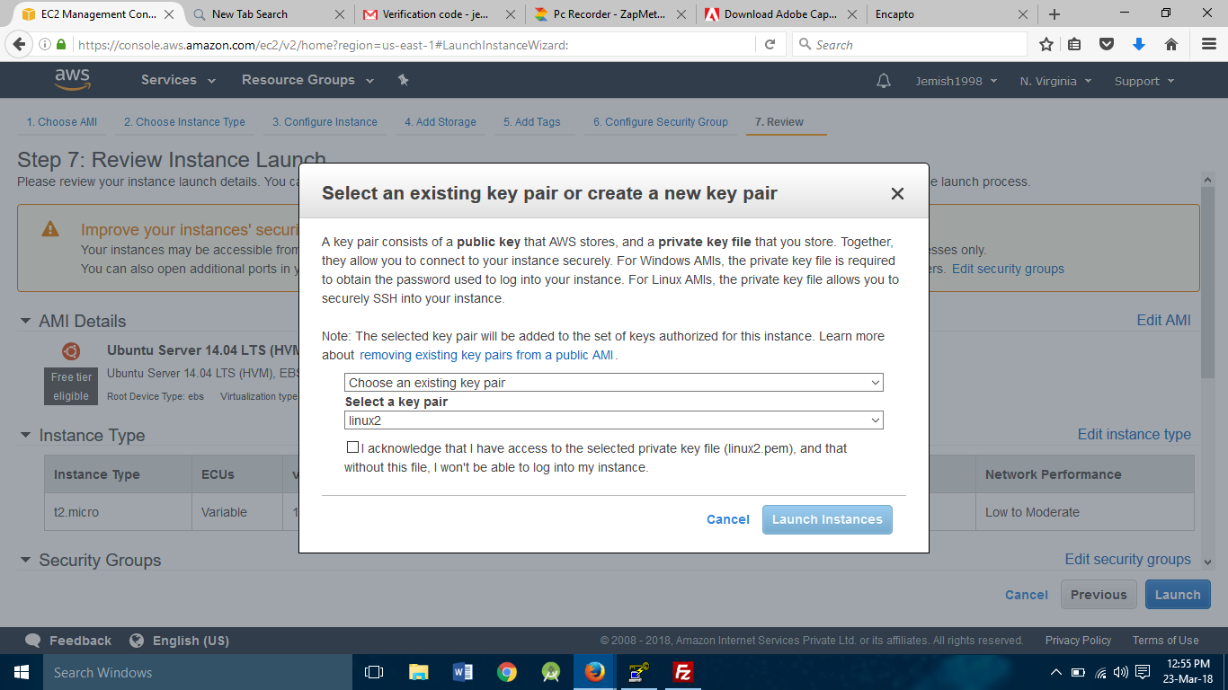

1. **Click On next: configure instance details than click on Next: Add Storage than add tags and configure security group , add rules and launch Instance.**

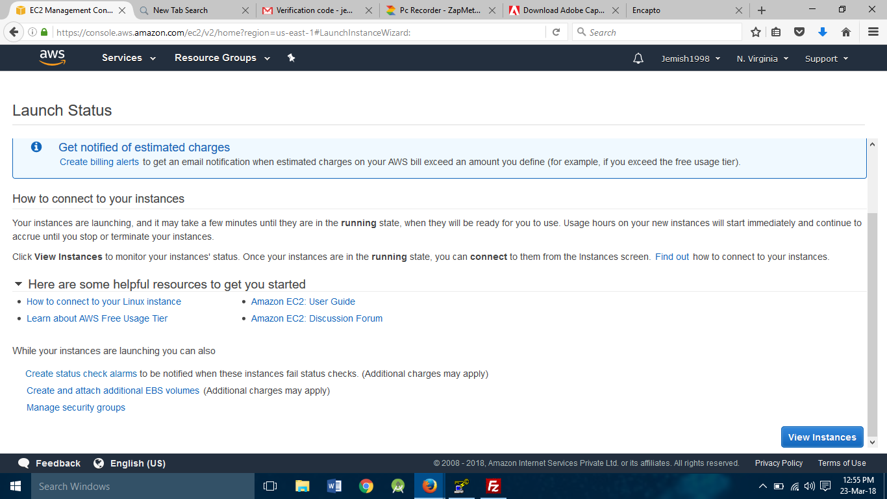

1. **Show Instance in EC2 Dashbord Connect Instance Using Putty.**

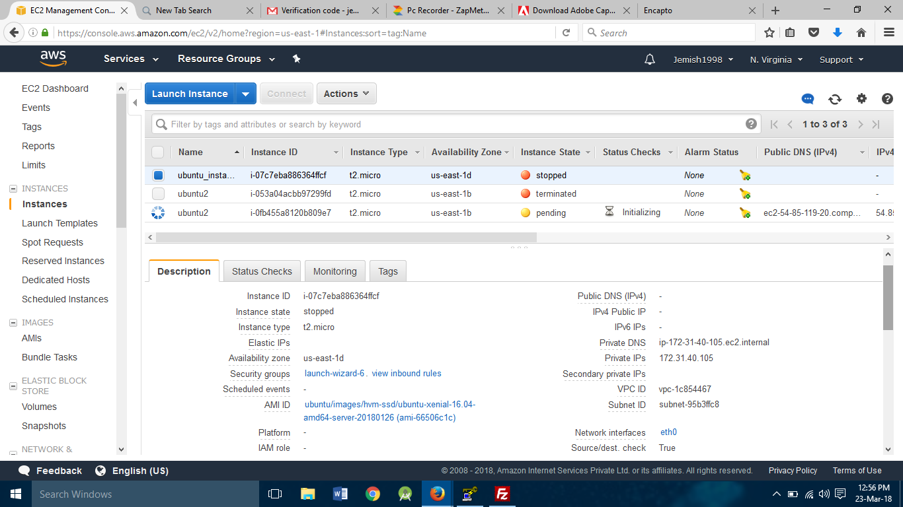

1. **Download Putty ,Puttygen and install it.**

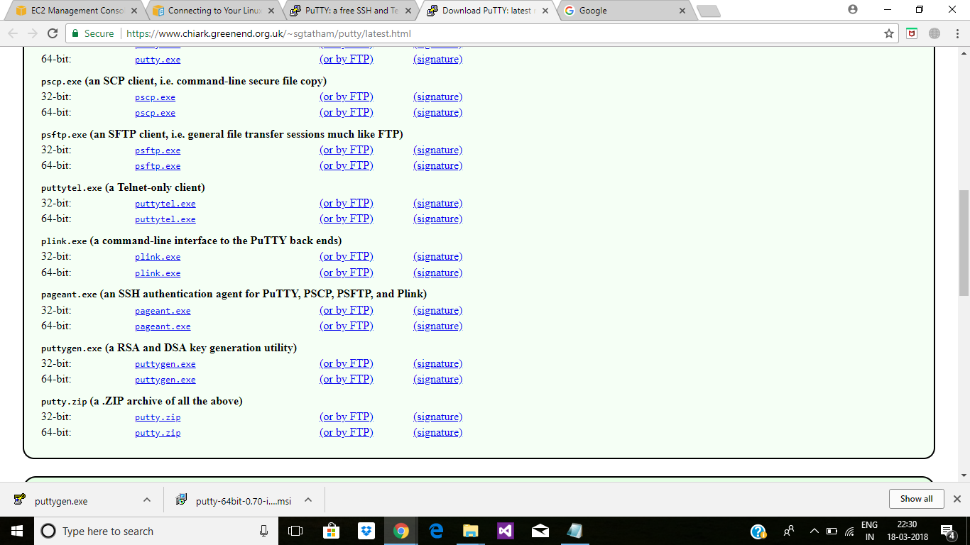

1. **Open puttygen.exe.**

**Load the Key When instance Generate**

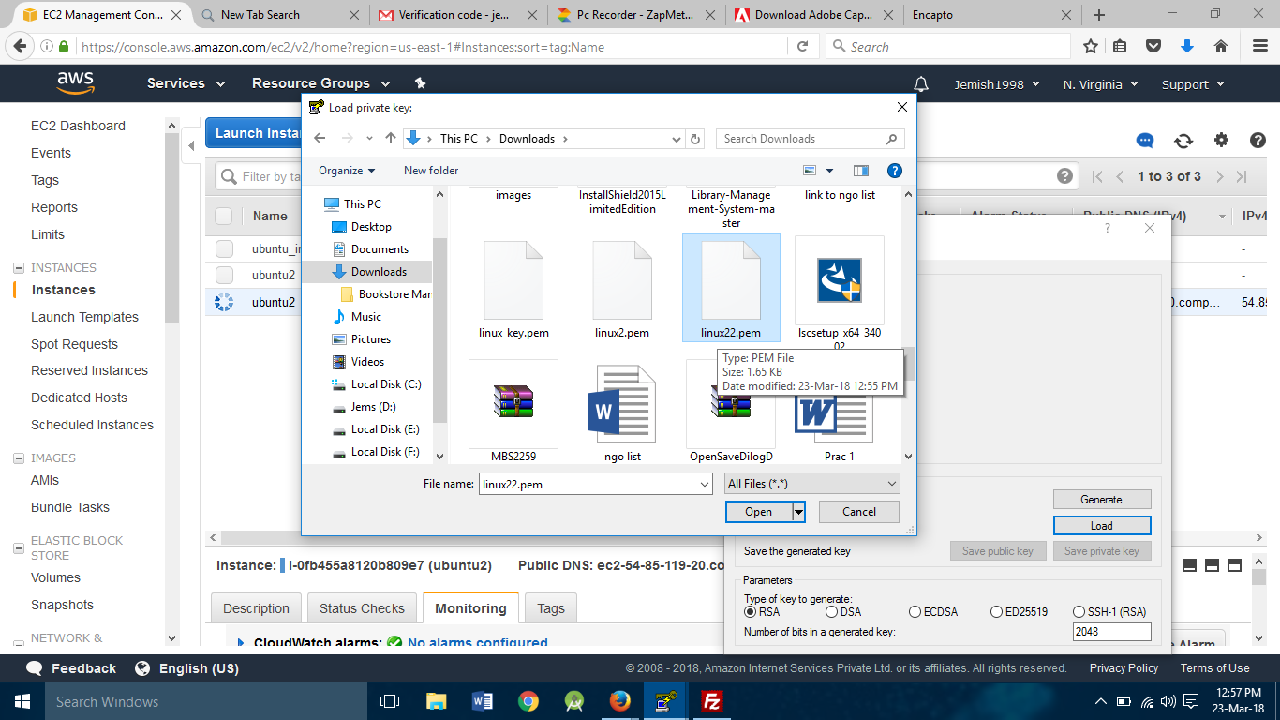

1. **Click on Load and add downloaded .pem file and click on ok.**

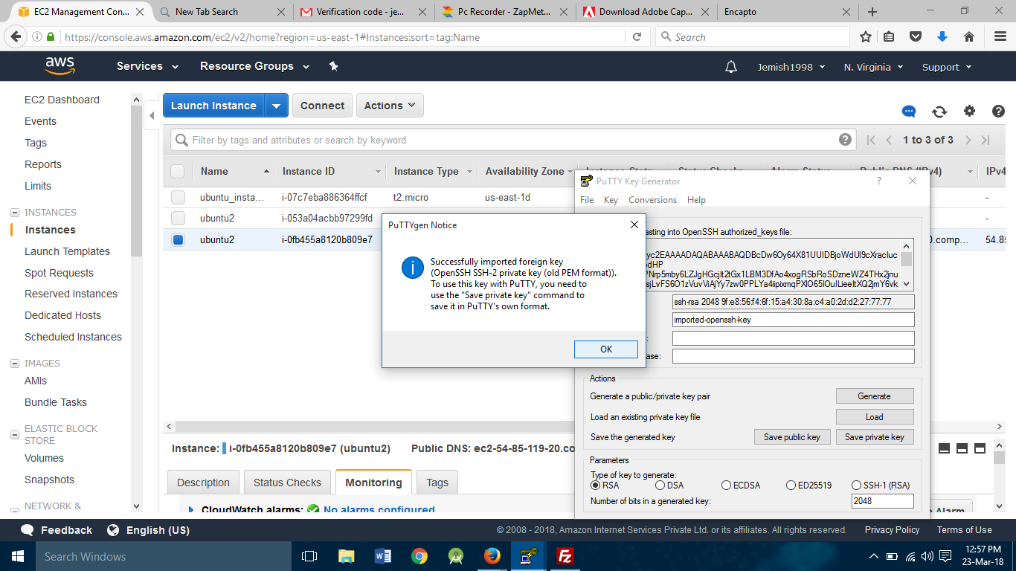

1. **Click On save private key**

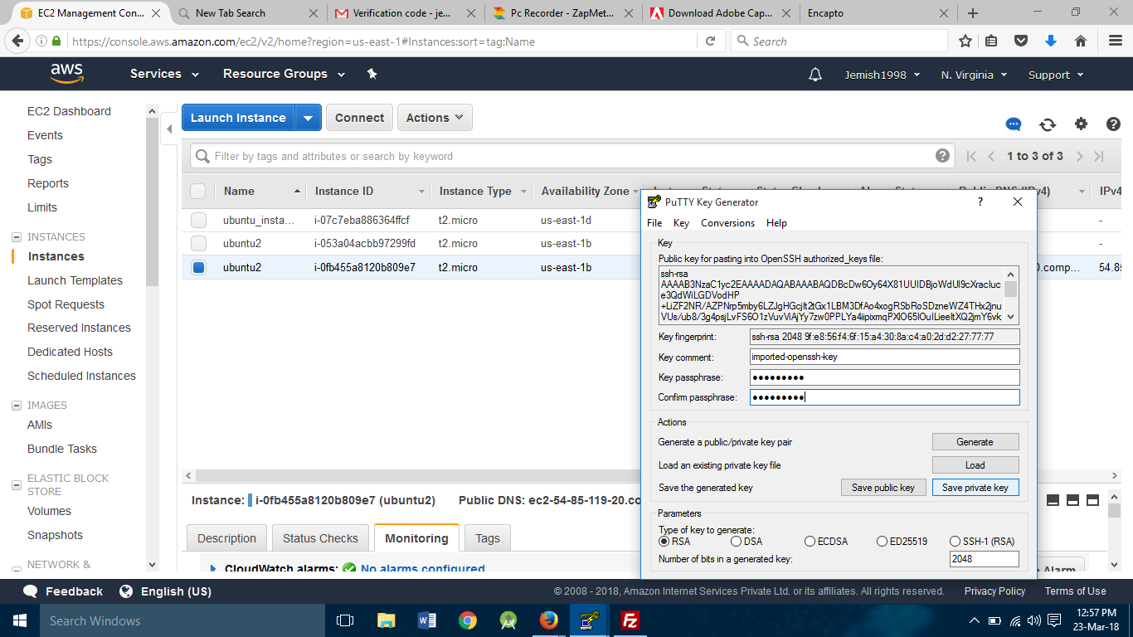

1. **Open Putty.exe and Copy public ip and paste it at host name**

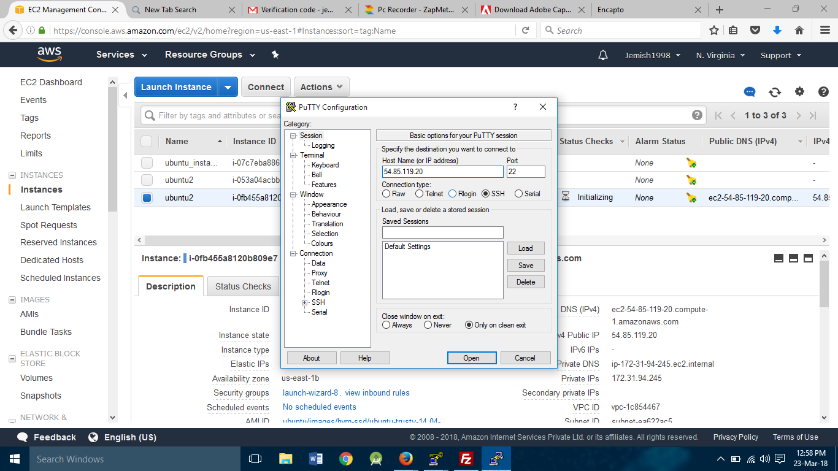

1. **Click on SSH->Auth->Browse->Select Saved .PPK file.**

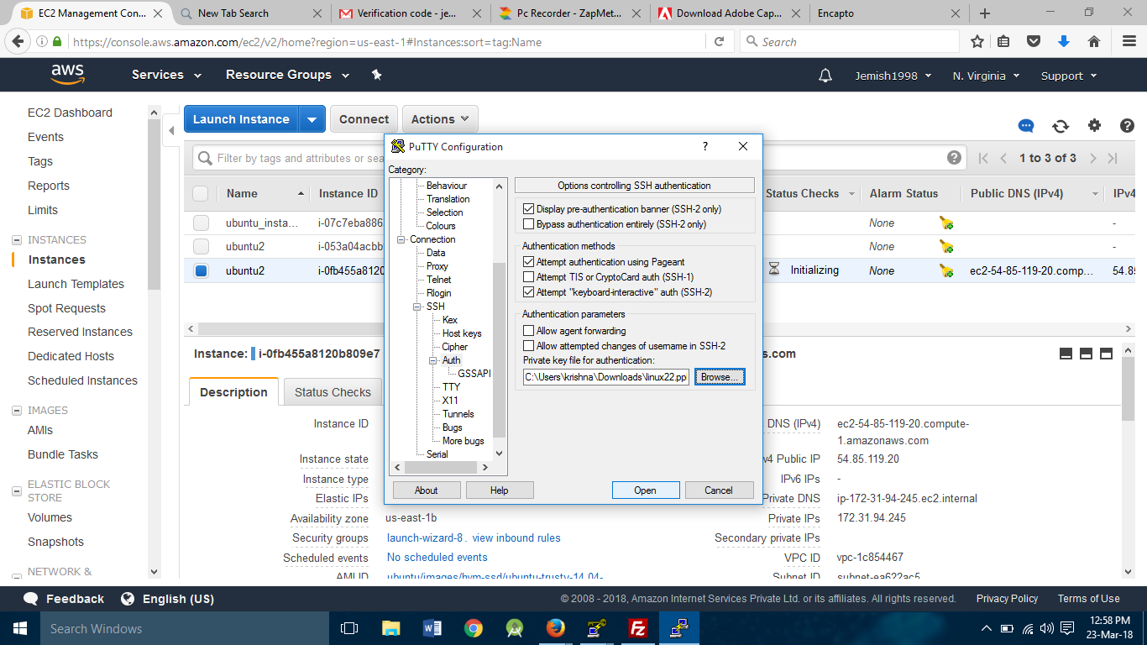

1. **Wait for Some time and it will start.**

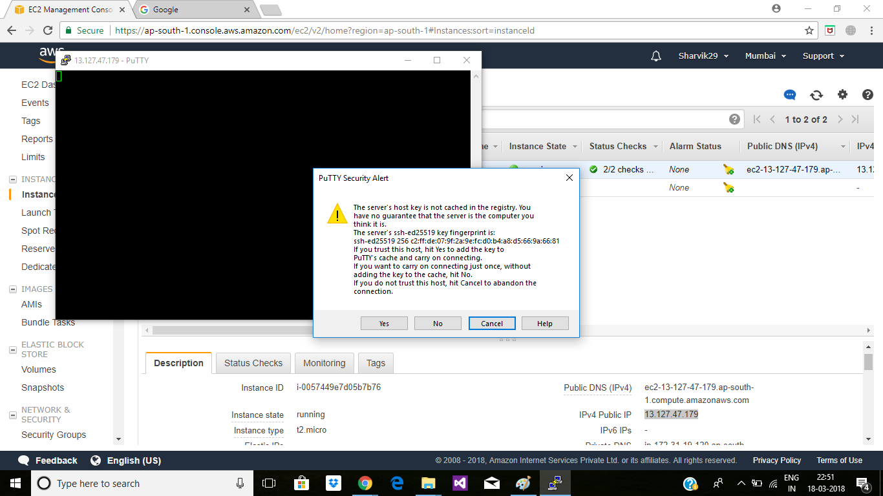

1. **Enter Login name: ubuntu**

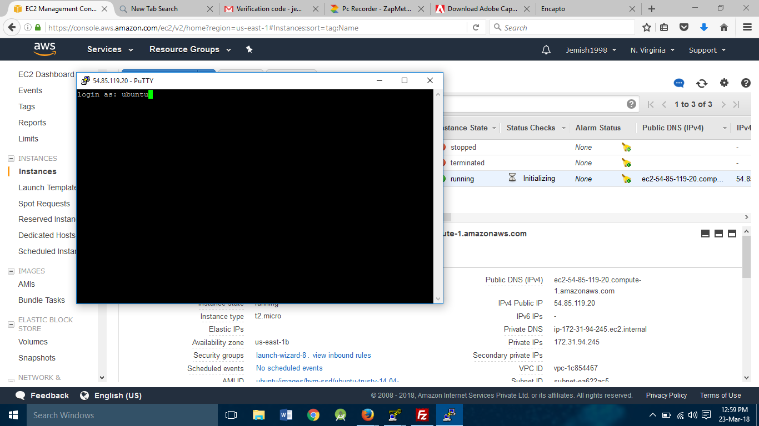

1. **Your Instance is connected.**

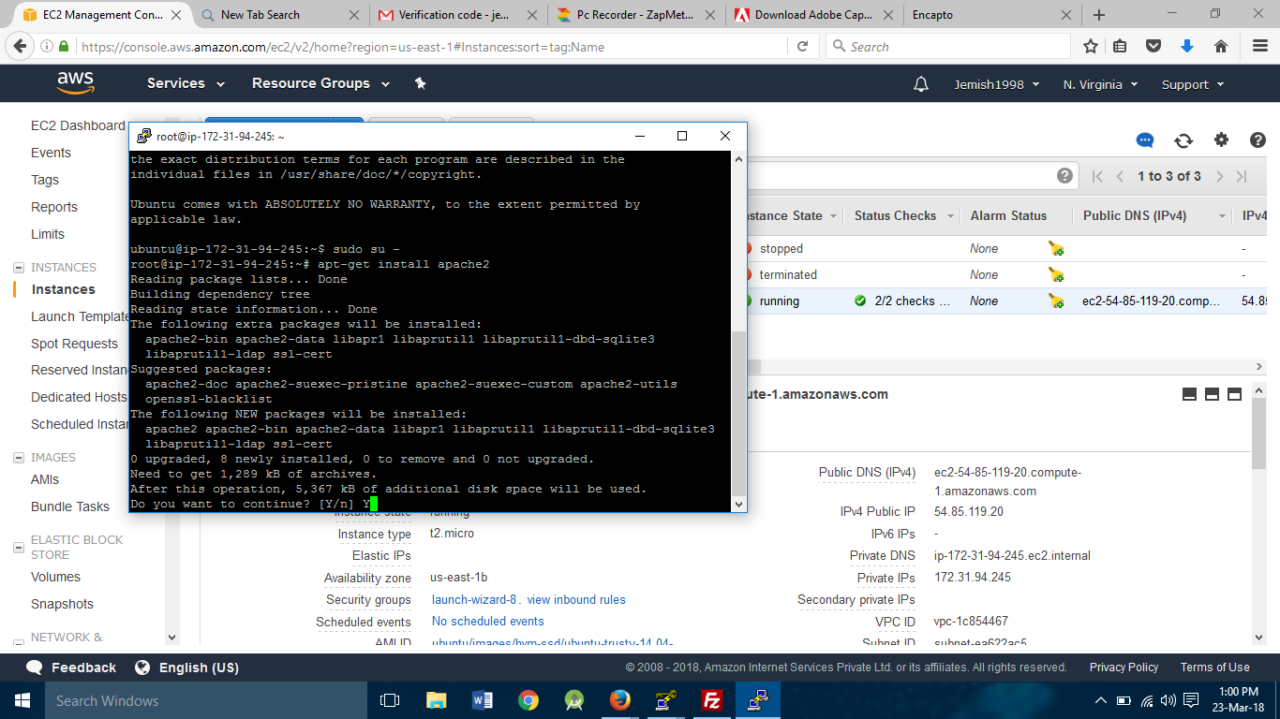

1. **Write Following commands in linux terminal:**

**sudosu –**

**apt-get install update**

**apt-get install apache2**

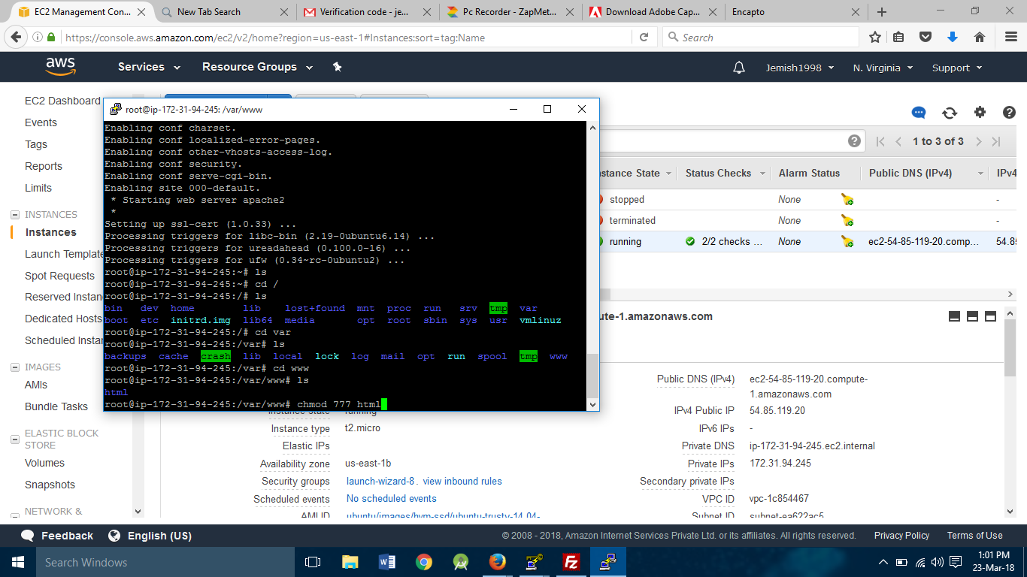

1. **Linux will open in your browser.**

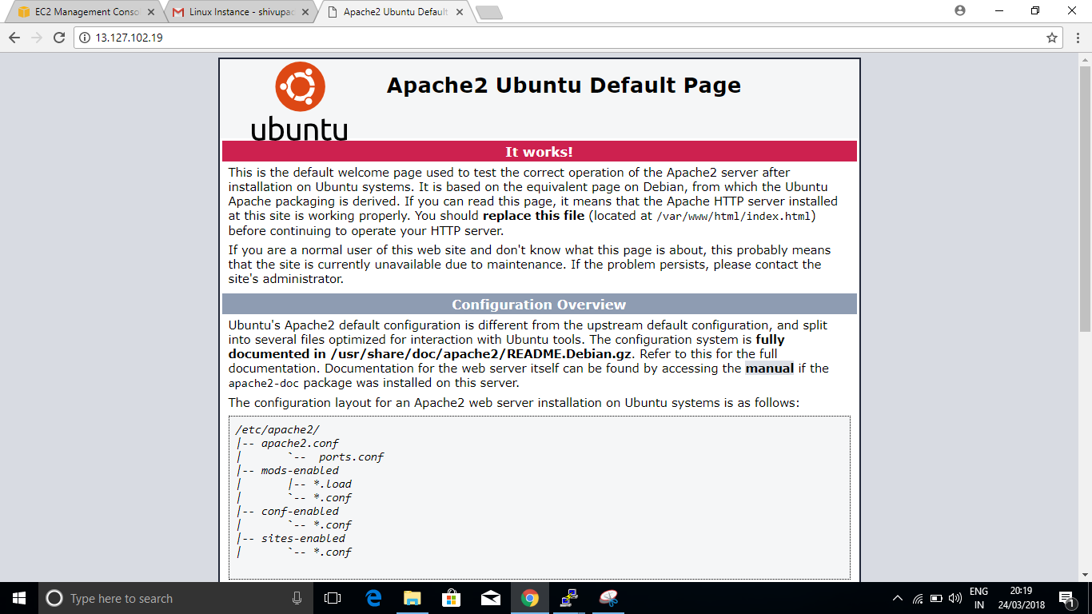

1. **Download and Install Filezilla.**

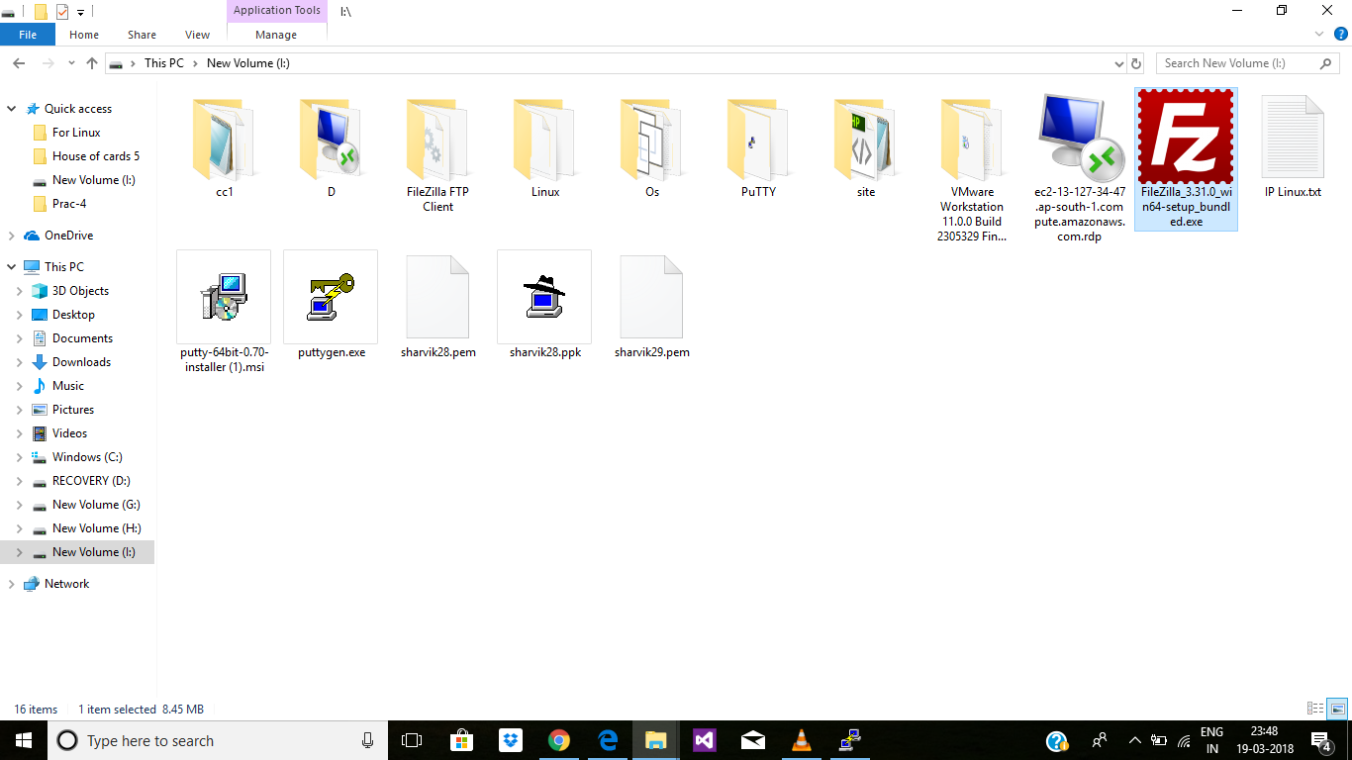

1. **Open Filezilla.**

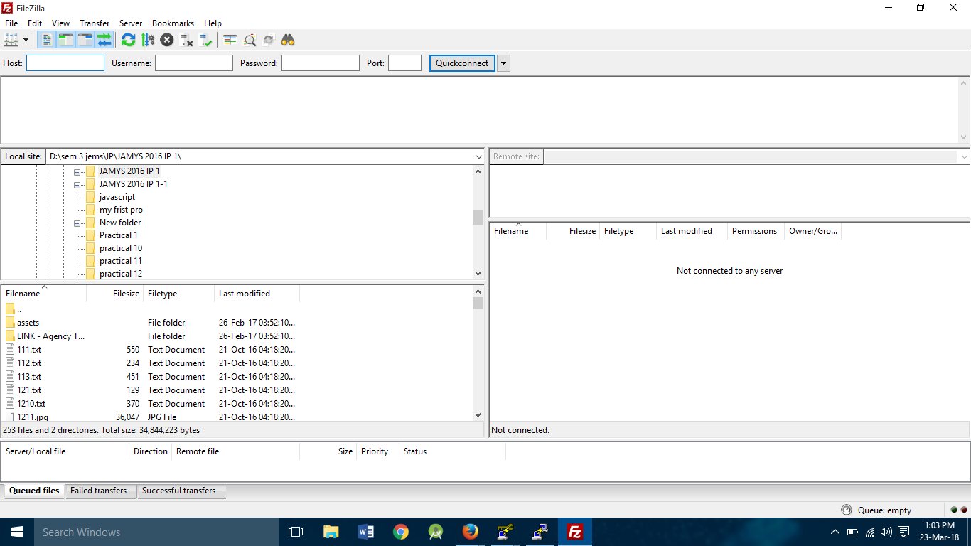

1. **Go to Edit->Settings->SFTP->Add Key File->Add .ppk file**

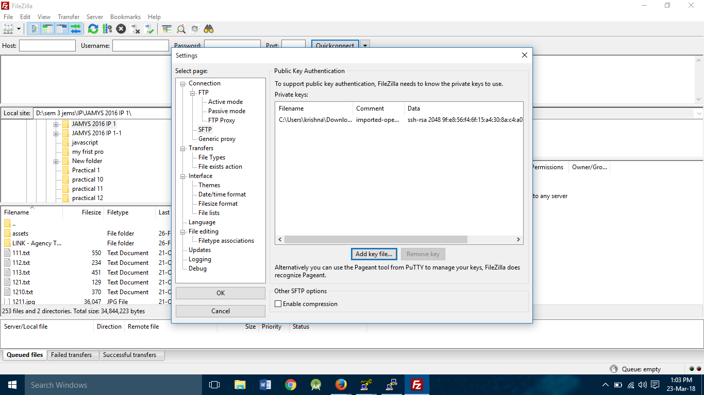

1. **Enter Hostname , username, port and click on quick connect.**

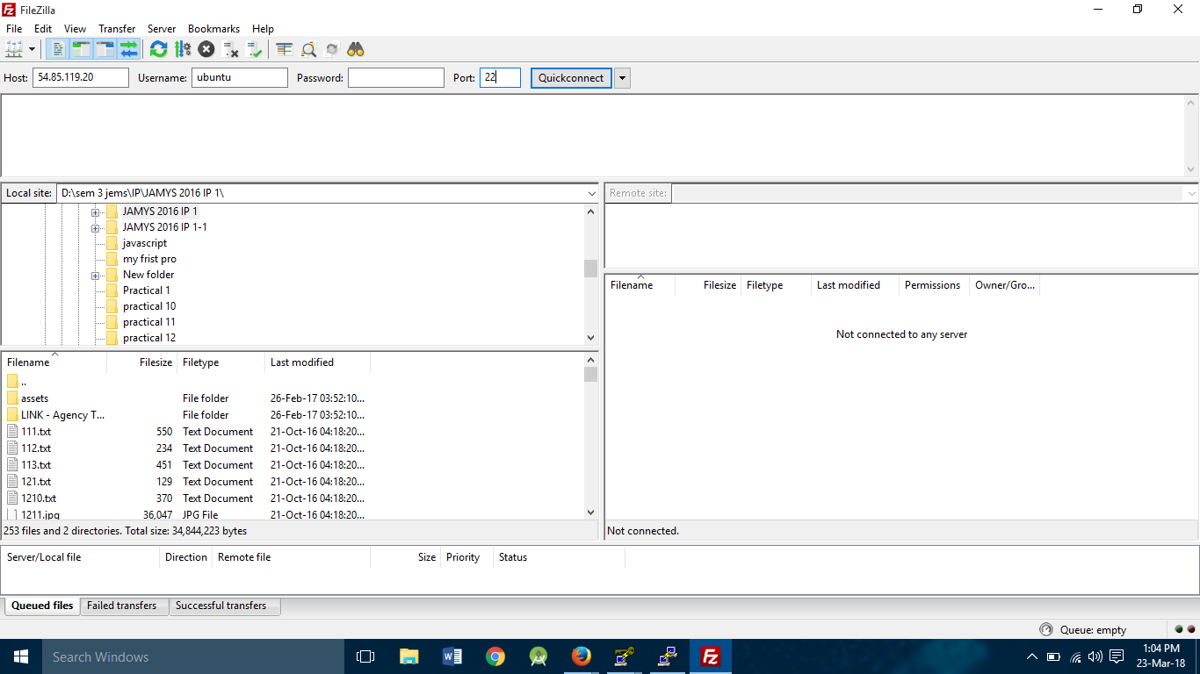

1. **After sometime server will connect.**

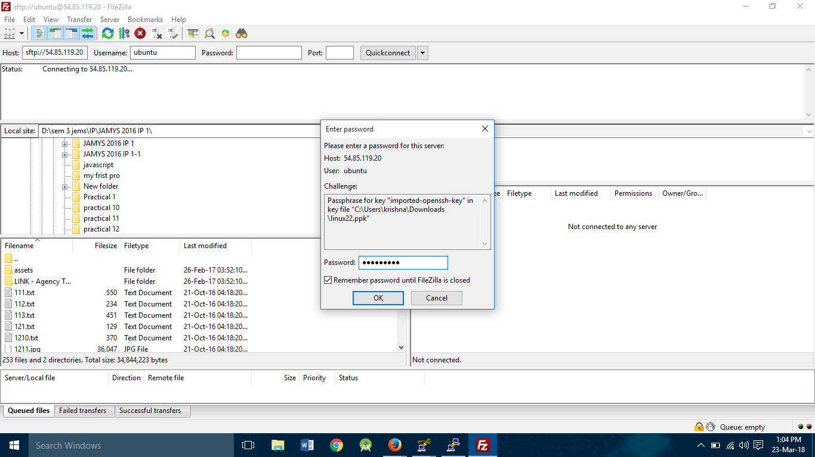

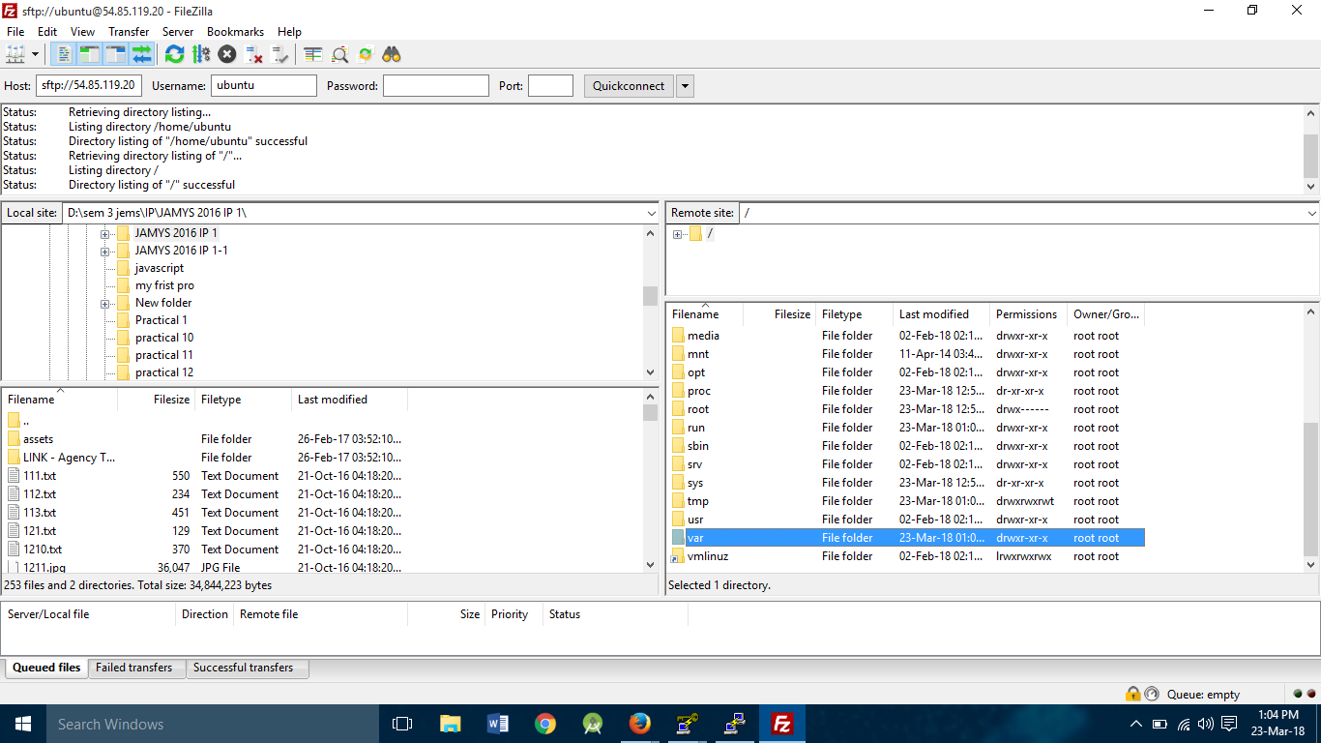

1. **Remove index.html file from server.**

**rm index.html**

**chmod 777 html**

**gotofilezilla terminal->right click->refresh**

**upload your website**

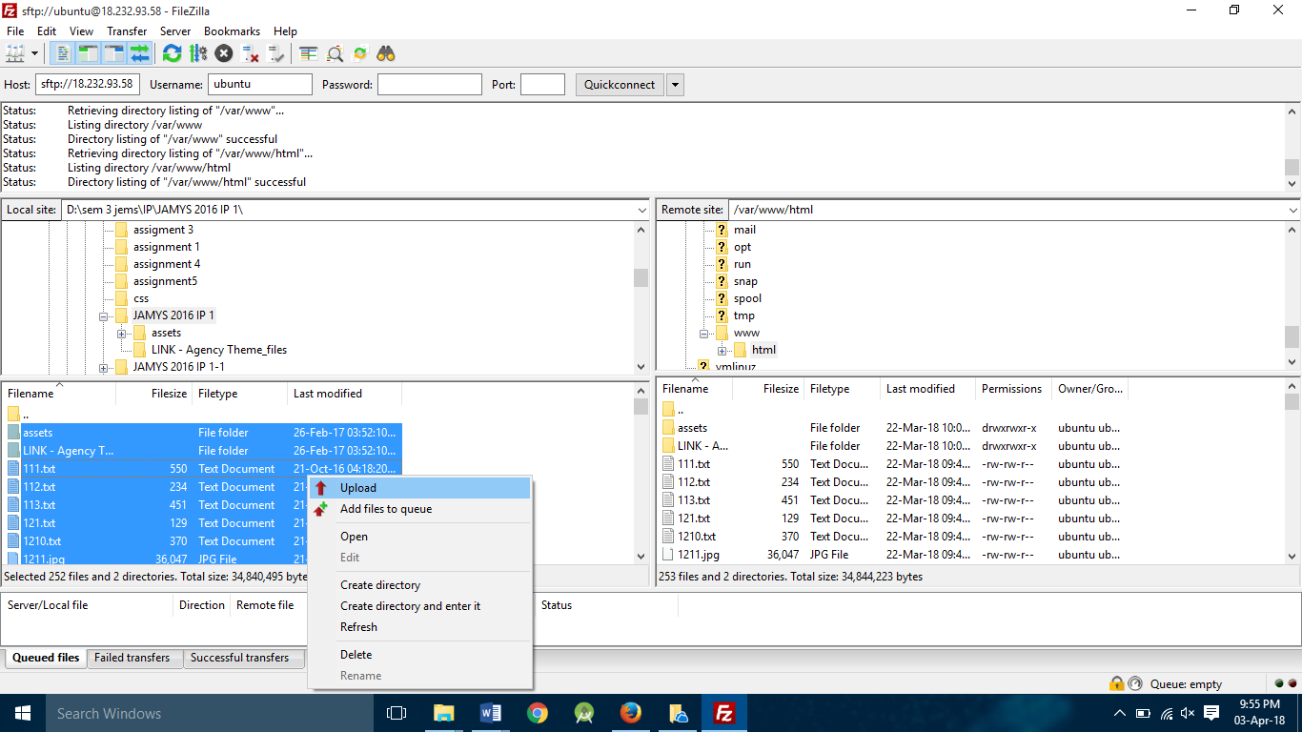

1. **Go to browser enter public DNS or public ip to check website is running or not.**

